

***P.5 SCIENCE LESSON NOTES TERM I***

POULTRY KEEPING

1. Poultry keeping is the rearing and management of domestic birds.
2. Poultry are the domestic birds.
3. Examples domestic birds; chicken, turkey, duck, guinea fowl, pigeon, geese. etc

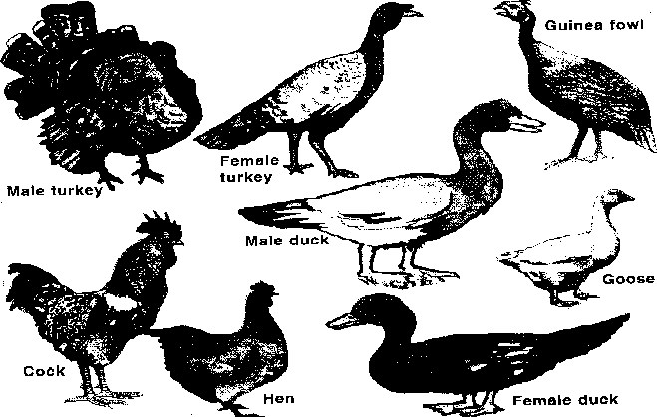

Reasons for keeping (poultry) domestic birds

1. Some birds are kept as pets.
2. Some birds are kept for egg production.
3. Some birds are kept for meat production.
4. Birds are also kept for generating income.
5. Droppings from poultry are used as manure.
6. Feathers from birds are used for decoration.
7. Some birds are kept for cultural purposes. eg. marriage, sacrifices.
8. The bones of some birds can be used in the making of buttons, glue and fertilizers.

The external parts (features) of a cock

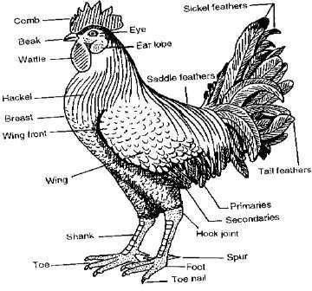

FEATHERS

There are four types of feathers: a. Quill feathers.

* 1. Covert feathers.
  2. Down feathers.
  3. Hair (filoplume) feathers.

The quill feather.

* 1. They are primary feathers.
  2. They are found on the tail and wings.
  3. They are used for flying ( flight)

Parts of a quill feather

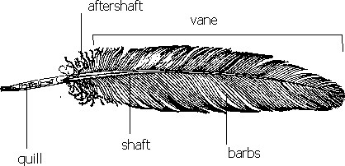

Covert feathers.

* 1. They are secondary feathers.
  2. They cover most of the bird’s body.
  3. They keep the bird warm.



The down feather.

* 1. They are the first feathers to appear on a chick.
  2. They help in insulating the bird’s body.

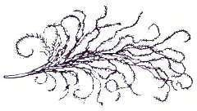

The filoplume (hair) feather.

* 1. They are tiniest feathers.
  2. They are found near the skin of the bird.

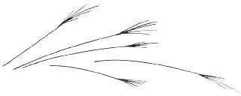

Uses of feathers to birds

1. The feathers enable the birds to fly.
2. Feathers cover the body of the birds.
3. Feathers protect the birds from bad weather.
4. Feathers keep the bird warm.
5. The feathers give the birds colour for identification.

Uses of feathers to man

1. Feathers can be used to make pillows, mattresses and cushions.
2. Feathers are used as writing materials.
3. Feathers are used for decoration.
4. Feathers are used to make craft materials.

TYPES OF CHICKEN REARED

A type of chicken is a class of chicken reared for a specific purpose.

There are three types of chicken reared: a. Layers.

* 1. Broilers
  2. Dual-purpose birds.

LAYERS

1. Layers are kept purposely for egg production.
2. Examples of layers:
   1. White leghorn.
   2. Brown egger.
   3. Thornber
3. Off-layers are birds whose egg production rate has greatly lowered.

BROILERS

1. Broilers are kept for meat production.
2. Broilers are also known as table birds.
3. Examples of broilers:
   1. Light sussex.
   2. Orpington
   3. Ply mouth rock
   4. Hampshire

DUAL PURPOSE BIRDS

1. Dual-purpose birds are kept for both meat and egg production.
2. Dual-purpose birds are both good layers and give a lot of meat.

BREEDS OF CHICKEN

A bread of chicken is a group of chicken with specific characteristics.

1. Birds with similar characteristics are said to be of the same breed.
2. The breeds of chicken can be divided into three:
   1. Local breeds (indigenous) breeds.
   2. Exotic (foreign) breeds.
   3. Crossbreeds.

Characteristics of local breeds

1. Local breeds take long to mature.
2. They are more resistant to diseases compared to exotic breeds.
3. They produce little meat and usually hard.
4. They produce fewer eggs compared to the exotic ones.
5. Local breeds have different feather colour.
6. They produce small eggs.
7. Local breeds can survive poor management conditions like:
   1. Little food.
   2. No shelter.
   3. High temperature.
   4. Little water.

EXOTIC BREEDS

1. These are breeds which were imported from foreign countries.
2. Exotic breeds are also known as foreign breeds.
3. Examples of exotic breeds include:
   1. Rhode island Red
   2. Light sussex
   3. White leghorn
   4. The New Hampshire
   5. The orpington
   6. Ancona

Characteristics of exotic breeds

1. They have tender meat.
2. They are good layers.
3. They grow and mature faster.
4. They can not stand poor management conditions.
5. They have a lot of flesh on them.
6. They are of the same colour, size and shape.
7. They are less resistant to diseases.

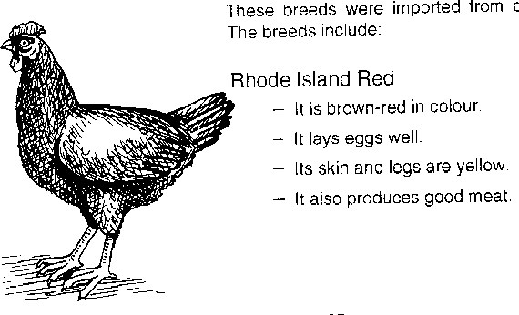

**Rhode island Red**



1.

2.

3.

It is white in colour.

It lays eggs well.

It is good for cross breeding.

* + 1. It is brown red in colour.
    2. It lays eggs well.
    3. Its skin and legs are yellow.
    4. It produces good meat.

Light Sussex The orpington

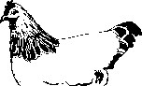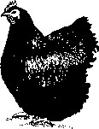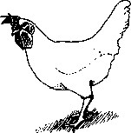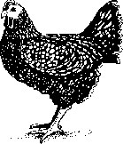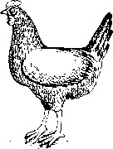White leghorn

It is black in colour.

It is an egg-laying bird.

Ancona

* + 1. It is white in colour.
    2. Its legs and beak are yellow. The New Hampshire

It is black in colour.

The tips of some feathers are white.

It is mainly used for cross breeding.

* + 1. It is lighter red in colour.
    2. It lays good eggs.

CROSS BREEDS

* 1. Crossbreeds are as a result of mating of two different breeds.
  2. The quality of local breeds can be improved by cross breeding.

SYSTEMS USED IN POULTRY KEEPING

a. Free range system.

* + - 1. Deep litter system.
      2. Fold pen system.
      3. Battery cage system.

FREE RANGE SYSTEM

Free-range system is the system where birds are allowed to roam about and look for their food.

Advantages of free range system

* 1. Birds get a variety of food which may enable them to get a balanced diet.
  2. Birds get enough physical exercises as they move round looking for their food.
  3. Free-range system cuts down the cost of feeding.
  4. Poultry vices such as cannibalism are reduced.
  5. Manure in form of poultry droppings is distributed all over the area birds feed from.

Note: Free-range system is the cheapest method in poultry keeping and management. That is why it is commonly practiced in rural areas.

Disadvantages of free range system

* 1. The birds can easily get diseases (easy spread of diseases) 2. The birds can easily be eaten by wild animals.
  2. The birds can get lost.
  3. Eggs can easily get lost.
  4. The birds can easily be stolen.

DEEP LITTER SYSTEM

* 1. This is a system of keeping large number of birds in a house whose floor is covered with

litter.

* 1. This is the most common method of poultry keeping used in Uganda for large scale production.

Materials used as litter.

* + - 1. Sawdust.
      2. Coffee husks.
      3. Wood shavings.
      4. Crashed maize cobs.

The structure of a deep litter house.

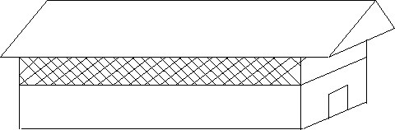

Inside a deep litter house

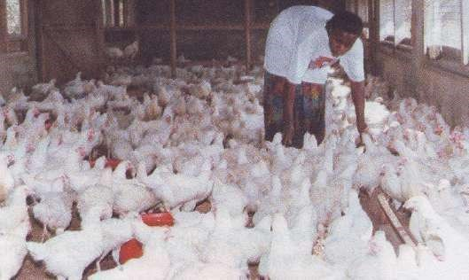

Things found in a deep litter house

* + - 1. Laying nests.

Laying nests or boxes for the birds to lay eggs.

* + - 1. Perches

Perches for the birds to play and rest.

* + - 1. Feeding troughs

Feeding troughs for placing poultry feeds.

* + - 1. Water troughs

Water troughs for the birds to drink water from.

* + - 1. Litter

The litter should be put on the floor regularly and replaced after sometime. Importance of litter in a deep litter house 1. To absorb moisture from chicken droppings.

* 1. To prevent eggs from breaking.
  2. To keep chicken busy scratching.

Disadvantage of litter

Litter habours vectors.

Advantages of deep litter system

* 1. Many birds can be kept in a small house (structure)
  2. Litter can be used as manure.
  3. Eggs don’t get lost.
  4. The birds are protected from wild animals. (predators).
  5. Eggs are easily collected from the laying boxes.
  6. It controls the spread of parasites and diseases. Disadvantages of deep litter system
  7. In case of an outbreak of a disease, it can easily spread.
  8. The system encourages poultry vices.
  9. It is difficult to keep individual hen’s production record.
  10. The litter can be a fire hazard (it can catch fire and burn the whole house)
  11. In case of a wet (rainy) season, the air is too humid thus making it difficult to keep the litter dry.

BATTERY CAGE SYSTEM

This is a system where one to four birds are kept in each cage.

Advantages of Battery cage system

* 1. The record of individual birds can be easily kept.
  2. Eggs don’t get lost.
  3. Easy identification of unproductive birds.
  4. Food and water cannot easily be contaminated by droppings.
  5. Control of parasites and diseases is easy.
  6. Poultry vices are greatly controlled.
  7. Culling birds is easy.

Disadvantages of Battery cage system 1. There is limited space for physical exercises.

* 1. It is expensive to construct cages.
  2. It is tiresome to feed the birds.

FOLD PEN SYSTEM

This is a system where a small number of birds are kept in a small movable house called cages, pens, arks, or folds.

A movable fold

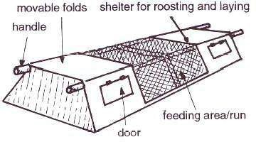

Advantages of Fold pen system

* 1. Birds are restricted from movements (kept under close observation).
  2. Manure is easily distributed on the farm.
  3. It is cheaper compared to the battery cage and deep litter systems.
  4. Parasites and diseases are easy to control.
  5. The folds are easy to make.

Disadvantages of Fold pen system

* 1. Only a small number of birds can be kept in a fold or an ark.
  2. It is tiresome to move the pen.
  3. The folds get old easily due to frequent movement.

POULTRY DISEASES AND PARASITES

1. Diseases in poultry are caused by:

* + - 1. Viruses
      2. Bacteria
      3. Protozoa

2. Factors that promote the spread of diseases in a poultry farm are:

* + - 1. Over crowding.
      2. Poor feeding.
      3. Poor housing.
      4. Contaminated water and feeds. Examples of poultry diseases a. Coccidiosis.
      5. Fowl pox.
      6. Fowl typhoid.
      7. New castle disease.
      8. Black head.
      9. Pneumonia.
      10. Gumboro.

COCCIDIOSIS

* 1. It is caused by protozoa.
  2. It attacks the lining of the small intestines and the liver.
  3. It is common to poultry, rabbits, kids, lambs and calves. Signs and symptoms of Coccidiosis
  4. Bloody diarrhoea.
  5. Rough feathers.
  6. Loss of weight (emaciation)

Prevention and control of Coccidiosis

* 1. Add coccidiostats in the feeds or water.
  2. Cull the infected birds.

BLACK HEAD

It is caused by Protozoa.

Signs and symptoms of black head

* 1. Yellowish diarrhoea.
  2. Dark purple head.
  3. Yellow green circular wounds (lesions)

Prevention and control of Black head

* 1. Avoid over crowding.
  2. Separate turkeys from fowls.

FOWL POX

* 1. It is an infectious disease caused by a virus.
  2. The virus enters the body through wounds brought about by biting insects and pecking.

Signs and symptoms of fowl pox

* 1. Tiny wounds on the wattle, comb and wings.
  2. Ulcers in the mouth.
  3. Difficulty in breathing.
  4. Eyes go sleepy and stuck.

Prevention and control of fowl pox

* 1. Routine vaccination.
  2. Ensure proper hygiene in the poultry house.
  3. Cull and slaughter the infected birds.
  4. Disinfect the poultry house.

NOTE: Fowl pox has no treatment.

NEW CASTLE DISEASE

* 1. It is a highly infectious disease caused by a virus.
  2. It kills unvaccinated poultry birds over a large area.

Signs and symptoms of New castle 1. Thick mucus discharged from the mouth.

* 1. Difficult breathing.
  2. Staggering with drooping wings and bending of the neck.
  3. Watery yellowish white diarrhoea.
  4. Reduction in egg production.

Prevention and control of New castle

* 1. Vaccinate the birds regularly.
  2. Kill the whole flock and disinfect the house.
  3. Isolate the sick birds.

NOTE: Newcastle disease has no treatment.

FOWL TYPHOID

* 1. This is a highly infectious disease in poultry caused by bacteria of salmonella group.
  2. The disease is transmitted to chicks by carrier hens through eggs.
  3. Salmonella also affects human beings, so it is dangerous to eat raw eggs.

Signs and symptoms of fowl typhoid.

* 1. White yellowish or green yellowish diarrhoea.
  2. Dullness and sleepy eyes.
  3. Drooping wings.
  4. The comb or the wattle gets shrunken and pale yellow.

Prevention and control of fowl typhoid 1. Testing and killing of the affected birds.

* 1. Keep the poultry house clean.
  2. Regular vaccination.

PNEUMONIA

* 1. Pneumonia is a contagious disease.
  2. it is caused by bacteria.

Signs and symptoms of pneumonia.

* + - 1. Watery discharge from the mouth part and nostrils.
      2. High temperature.
      3. Coughing
      4. Difficulty in breathing
      5. Loss of appetite

Prevention and control of pneumonia a. Treat with antibiotics.

* + - 1. Keep the poultry house warm during cold seasons.
      2. The poultry house should be well ventilated.
      3. Isolate the sick ones.

Summary table of poultry diseases and their cause.

|  |  |  |  |
| --- | --- | --- | --- |
| CAUSE | VIRUS | BACTERIA | PROTOZOA |
| DISEASES | 1. Fowl pox. 2. New castle | 1. Fowl typhoid 2. Pneumonia | 1. Coccidiosis 2. Black head |

General methods of controlling poultry diseases

* 1. Regular vaccination against diseases like New Castle, fowl pox etc.
  2. Isolate the sick or infected birds.
  3. Culling of the infected birds.
  4. Disinfecting and maintenance of cleanliness of poultry houses.

PARASITES IN POULTRY

* 1. Parasites are living organisms that depend on other living organisms for food and shelter.
  2. A living organism on which the parasites depend on is called a host.

Types of parasites.

* + - 1. Ecto parasites (external parasites)
      2. Endo parasites (internal parasites)

Ecto parasites (external parasites) in poultry

* 1. These are parasites that attack birds from outside the body.
  2. Examples of ecto parasites in poultry include:
     + 1. Lice
       2. Mites
       3. Fleas

Prevention and control of ecto parasites

* 1. By dusting using pesticides.
  2. Sodium fluoride is the pesticide commonly used to kill ecto parasites in poultry birds. Endo parasites (internal parasites) in poultry
  3. These are parasites that attack the birds from inside the body.
  4. Examples of endo parasites in poultry include:
     + 1. Tape worms
       2. Round worms.

Prevention and control of endo parasites

* 1. Poultry farmers control endo parasites by deworming.
  2. Deworming is the practice of removing internal parasites.

VICES IN POULTRY

Vices are bad habits in poultry.

Examples of poultry vices a. a. Egg eating.

* + - 1. Cannibalism
      2. Toe pecking.
      3. Feather pecking
      4. Skin pecking. Causes of poultry vices
      5. Over crowding of birds.
      6. Poor feeding (little or no food)
      7. Boredom.

CANNIBALISM

This is where birds kill and eat their fellow birds.

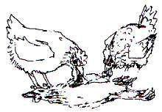

Sign of cannibalism 1. 1. Blood stains on the beaks.

* 1. Chicken bleed at the vent.
  2. Fighting among birds.

Prevention of cannibalism

* 1. Hang bundles of fresh vegetables to keep the birds busy.
  2. Debeaking should be done.
  3. Isolate the pecking birds and the pecked birds.

EGG EATING

This is where some layers eat their eggs.

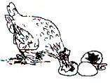

Signs of egg eating

* 1. Yellow stains on the beaks.
  2. Eggshells in the poultry room.

Prevention of egg eating

* 1. Debeak the birds.
  2. Provide laying boxes.
  3. Identify the egg eaters and remove them from the house.
  4. Keeping laying boxes in the dark.

FEEDING CHICKEN

The feeds given to poultry birds should be of a balanced diet containing: a. Proteins

* + - 1. Carbohydrates
      2. Vitamins
      3. Mineral salts

A structure of a drinking trough A structure of a feeding trough

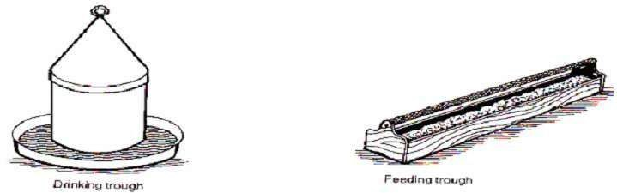

POULTRY FEEDS

There are four types of feeds commonly given to poultry birds:

* + - 1. Chick or starters’ mash. c. Layers’ mash.
      2. Growers’ mash. d. Broilers’ mash.

Chick or starters’ mash.

* 1. This is fed to chicks between the age of one day to eight weeks.
  2. It is rich in protein. Growers’ mash.
  3. Chicks from 9 weeks are referred to as growers.
  4. Such chicks are fed on growers’ mash. Layers’mash.
  5. This poultry feed is specially prepared for the birds that lay eggs.
  6. This poultry feed has a high mineral content.
  7. A layer lacking calcium usually produces eggs with soft eggshells.

Broilers’ mash.

This is a special feed for broilers.

THE DIGESTIVE SYSTEM OF A DOMESTIC FOWL

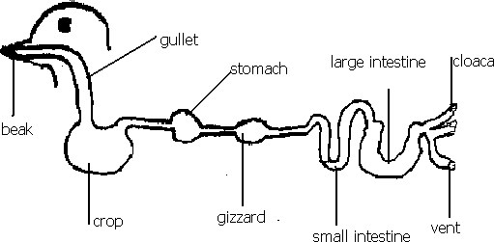

Functions of different parts

* 1. Beak

Picks the food for the bird.

* 1. Gullet

Passes food to the crop

* 1. Crop
     + 1. Stores food.
       2. Food is moistened and softened.
  2. Gizzard
     + - 1. Food is crashed into smaller particles by the grits.
         2. Grits are small stones found in the gizzard.
  3. Small intestines

Digestion is completed here and food is absorbed into the body.

* 1. Large intestines.

Absorbs water.

6. Vent

Passes out waste products.

POULTRY MANAGEMENT PRACTICES

* 1. These are routine activities that a poultry farmer carries out to maintain good production and avoid loses.
  2. These activities include:
     + 1. Debeaking
       2. Deworming and dusting
       3. Egg collection
       4. Culling
       5. Regular feeding
       6. Record keeping

1. Debeaking

* + - 1. This is the cutting short of the bird’s beak.
      2. Farmers debeak to avoid or prevent egg eating, pecking and cannibalism.

Drawing of a debeaked bird

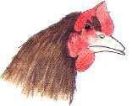

* 1. Deworming and dusting

These are done to control endo and ecto parasites respectively.

* 1. Egg collection

Eggs should be collected at least 2 to 3 times a day to avoid the following: a. Egg eating.

* + - 1. Breakage of the eggs.
      2. Eggs getting dirty.

Culling

* + - 1. Culling is the removal of the unproductive and infected birds from the flock.
      2. This can be done by selling, killing or slaughtering the effected birds.

4. Regular feeding

A farmer should provide both commercial feeds and green vegetables to birds at regular times.

FARM RECORD KEEPING

This is the keeping of information regarding the farm.

Types of farm records

* + - 1. Production record.
      2. Health record.
      3. Sales and expense record.
      4. Flock record.
      5. Feed record.

Production record

This shows the number of eggs collected daily.

Health records

These indicate the treatment given to birds e.g vaccination or deworming.

Sales and expense records

These show the expenditure and income from feeds, eggs, labour etc.

Flock records

These indicate the total number of live, sold, killed or dead birds every day.

Feed records

These show the type of feed, quantity of feed eaten and the quantity of spoilt feed. Reasons for keeping farm records

1. Records help the farmer to know whether the farm is making profits or losses.
2. Records help the farmer to identify areas that need improvement.
3. Records help the farmer to budget for the farm.
4. Records help the farmer to know the expenditure on the farm
5. Records help the farmer to plan for the farm.
6. Records help the farmer to avoid repeating mistakes.
7. Records help the farmer to easily get loans from Banks.
8. Records help the farmer to be taxed fairly.

REPRODUCTION IN POULTRY

Birds reproduce by laying eggs.

The structure of an egg

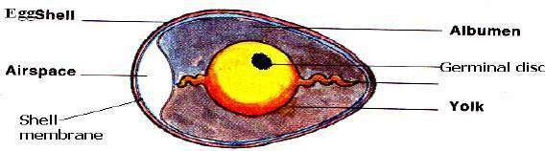

Functions (uses) of parts of an egg

1. Eggshell
   1. It protects the internal parts of an egg.
   2. An egg shell allows exchange of gases because it is porous.

An experiment to prove that an eggshell is porous.

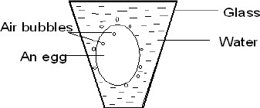

1. Germinal disc

It develops into an embryo after fertilization

1. Embryo

Develops into a chick.

1. Air space

It keeps and provides air to the embryo.

1. Chalaza

It holds the yolk in position.

1. Yolk

It is the source of proteins and fats for the embryo.

1. Albumen (egg white)

It is the source of water and proteins to the embryo.

ABNORMALITIES IN POULTRY EGGS a. Soft eggshells.

* 1. Double yolk.
  2. Blood stains in the eggs.
  3. Meat spots in the eggs

INCUBATION

1. Incubation is the process by which a fertilized egg is given favourable conditions to hatch.
2. Incubation period is the time taken for a fertilized egg to hatch.

Incubation periods of some domestic birds a. A hen – 21 days (3 weeks)

* 1. A duck – 28 days (4 weeks)
  2. A turkey – 28 days (4 weeks)
  3. A goose – 30 days ( 1 month)

Types of incubation in chicken a. a. Natural incubation.

b. Artificial incubation.

NATURAL INCUBATION IN CHICKEN

1. This is where by a mother bird sits on eggs to provide necessary conditions for hatching.
2. Illustration of natural incubation.

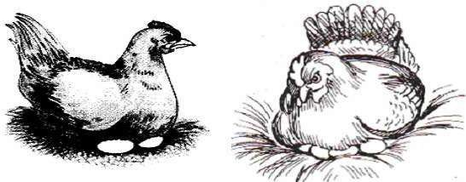

1. Conditions needed for natural incubation.
   1. The eggs must be fertilized.
   2. The nest should be clean, dry and comfortable.
   3. The place should have dim light.
   4. The place should be free from strong wind.
   5. The place should be free from vermins e.g snakes and rats.

Advantages of natural incubation in chicken

1. The incubating hen needs little attention.
2. It is cheap and manageable.
3. One does not bother with brooding the chicks.

Disadvantages of natural incubation in chicken

1. Few eggs are incubated.
2. Natural incubation can not be used for commercial farming.
3. The mother hen may not be good at incubating.
4. The incubating hen can be attacked by vermins.

ARTIFICIAL INCUBATION IN CHICKEN

1. This is the method where a machine is used to hatch the eggs.
2. An incubator is the machine used to hatch eggs.

An electric incubator Local incubator

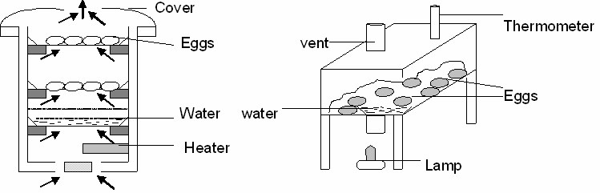

Advantages of artificial incubation in chicken

1. Many eggs are hatched once.
2. It is used for commercial purposes.
3. Eggs are free from vermin.

Disadvantages of artificial incubation in chicken

1. It is expensive to buy an incubator.
2. A lot of attention is needed.
3. It needs qualified workers.

BROODING CHICKS

Brooding is the special care given to chicks from hatching time up to nearly 8 weeks.

Types of brooding

* 1. Natural brooding.
  2. Artificial brooding.

NATURAL BROODING IN CHICKEN.

1. This is a method where a mother hen takes care of her chicks.
2. She provides warmth, security and looks for food for the chicks.
3. When the chicks have grown, they are left on their own.
4. An illustration of natural brooding.

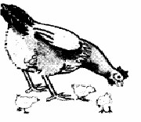

Advantages of natural brooding in chicken.

1. It is cheap in terms of expense and attention.
2. The hen looks for food for its chicks.
3. The chicks get security from the mother hen.
4. Toe pecking is reduced in chicks because they move with their mother.

Disadvantages of natural brooding in chicken.

1. Chicks can be eaten by wild animals.
2. It cannot be used on large scale.
3. The mother hen can be killed and leaves the chicks on their own.

ARTIFICIAL BROODING.

1. This is a method where chicks are kept in a brooder.
2. A brooder is a special structure where chicks below 8 weeks of age are cared for.
3. There are two types of brooders:
   1. Kerosene (paraffin) brooder)
   2. Infrared lamp brooder.

A local brooder

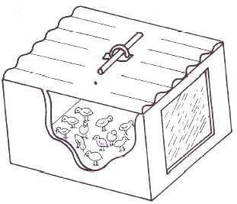

Disadvantages of a Kerosene (paraffin) brooder)

1. It needs a lot of close attention.
2. Lamp without guards can burn the chicks.
3. Soot from the lamp can accumulate in the brooder. Infrared lamp brooder
4. Electricity is the source of light and warmth in the brooder.
5. The infrared lamp is hanged at the ceiling, the height of the lamp is adjusted upwards as the chicks grow.

The structure of an infrared lamp brooder

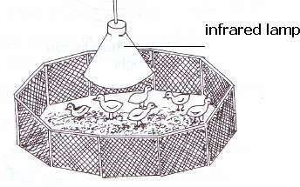

The purpose of the lamp in a brooder

1. To provide chicks with light.
2. To provide warmth to the chicks.

Behavior of chicks in a brooder

1. When it is cold, the chicks crowd together or around heat source.
2. When it is hot, the chicks roam around.

NOTE: In both brooding systems, chicks should be vaccinated.

COMMON TERMS USED IN POULTRY KEEPING 1. 1.Hen

A hen is an adult female domestic fowl.

1. Cock
   1. cock is an adult male domestic fowl.

1. Chick
   1. chick is a young one of a hen.

1. Cockerel
   1. cockerel is a young male domestic fowl from 8 weeks onwards.
2. Capon
   1. capon is a castrated male domestic fowl.

1. Pullet
   1. pullet is an immature female domestic fowl.

1. Incubation

Incubation is a process by which a fertilized egg is given favourable conditions to hatch.

1. Brooder
   1. brooder is a man made structure where chicks below 8 weeks are cared for.

1. Moulting

Moulting is the process by which birds shed their feather to replace them.

1. Broilers

Broilers are birds reared mainly for meat production.

1. Layers

Layers are birds reared purposely for egg production.

1. Culling

Culling is the removal of the sick or unproductive birds from the flock.

BEE KEEPING

1. Apiculture is keeping and management of bees.
2. Honeybees are social insects.
3. Social insects are insects that live and work together.
4. Other examples of social insects:
   1. Termites.
   2. Ants
   3. Wasps.
5. Insects that do not live and work together are called Solitary insects.
6. Examples of solitary insects:
   1. Butterfly
   2. Housefly
   3. Mosquito
   4. Cricket Types of bees

There are three types of bees:

* 1. Queen bee.
  2. Drone bee.
  3. Worker bee

|  |  |
| --- | --- |
|  | QUEEN BEE |

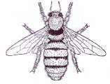

1. The main function of a queen bee is to lay eggs.
2. A queen bee mates only once in its lifetime.
3. It stores sperms in a sperm sac in the abdomen.
4. Its wings are shorter compared to its body.
5. It is larger than the drone and the worker bees.
6. A queen bee is fed on a special food called Royal jelly.

DRONE BEE

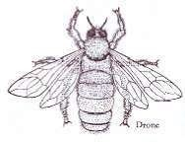

1. This is the male bee whose main function is to mate with the queen bee.
2. A drone bee is more hairy than the worker bee.
3. It has a blunt abdomen without a sting.
4. A drone bee makes a buzzing sound when flying.
5. A drone bee is not often found in the hive because it is killed after mating with the queen and its body is removed from the hive.

WORKER BEE

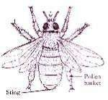

1. The worker bees are sterile (barren) female bees.
2. Worker bees are small in size but very many in numbers.

Duties of a worker bee

1. Worker bees build the comb using wax. The comb is divided into small hexagonal apartments called cells.

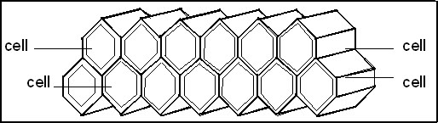

1. Worker bees feed the queen bee and the young ones in the brood (grub).
2. Worker bees clean the hive.
3. Worker bees guard and protect the hive.
4. They look for nectar, water and propolis. Propolis is a sticky substance collected from various trees.

Uses of propolis

* 1. It is used to smoothen the interior of a hive.
  2. It is used to waterproof the brood cells.
  3. It is used to repair the cracks in the hive.

Note: worker bees feed on pollen.

SWARMING

1. Swarming is the movement of bees in a group from one place to another looking for a hive.
2. A swarm is a group of bees.

Reasons to why bees swarm

* 1. Over crowding of bees in the hive.
  2. Dampness in the hive.
  3. Lack of proper ventilation.
  4. Excessive heat in the hive.
  5. When a queen becomes old and less productive.
  6. When a new queen is groomed.
  7. When the brood cells are damaged.
  8. Smoke near the hive.
  9. Too much noise in the area.
  10. Shortage of food and water near the hive in the area.
  11. Leakage in the hive.
  12. Attack by enemies.
  13. Bad smell around or in the hive.

n.

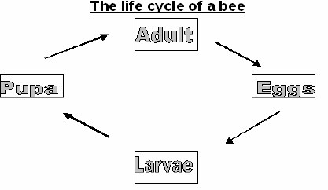

1. The queen bee lays the eggs in the cells.
2. The eggs hatch into the larvae (grub). The larvae are fed by the worker bees and sealed in the cells.
3. The larvae develop into the pupa.
4. The pupa then develops into a young bee.

Note: The grub is fed on honey.

BEEHIVES

Types of hives:

* 1. Traditional hives.
  2. Modern hives.

Examples of traditional hives:

a. Kigezi hive. b. The dug out log hive.

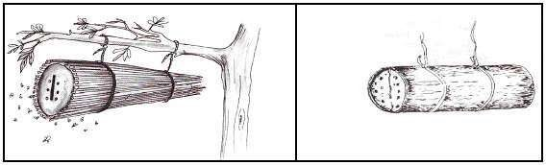

Examples of modern hives.

a. Top-bar hive

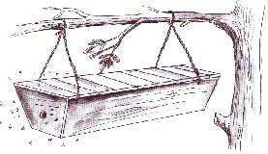

Advantages of top-bar hive over other hives

1. Honey collected is often of high quality.
2. The bars can be removed individually for inspection.
3. Harvesting of honey is easily done.
4. It avoids wastage of combs that are not ready.

The internal structure of a modern hive

1.

A brood chamber contains the

following:

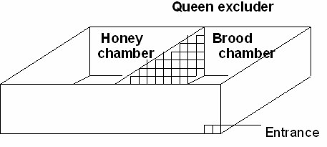

* 1. Eggs b. Larvae
  2. Pupa c. Young bees.
  3. The queen excluder prevents the queen from laying eggs in the honey chamber.
  4. The queen excluder is made-up of small wire mesh, which does not allow the queen to pass through but only the worker bees.
  5. The honey chamber is basically for honey.

HARVESTING HONEY

1. Honey harvesting is the removal of honey from a hive.
2. Care should be taken when harvesting honey because bees can sting if they are disturbed.
3. When harvesting honey, one should have the following:
   1. Bee veil. e. Gum boots.
   2. Gloves. f. A knife.
   3. Overall
   4. Basket or bucket
   5. A smoker.

A person ready to harvest honey

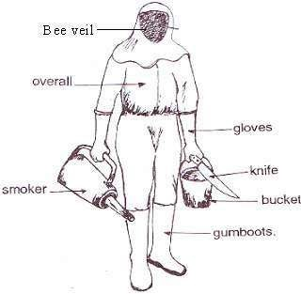

Products from bees

* 1. Honey
  2. Bee wax
  3. Pollen

Uses of honey in homes 1. Honey is used to sweeten tea.

1. Honey is used to bake bread.
2. Honey is used to make alcoholic drinks.
3. Honey is added to cereals and used to sweeten grape foods and fruit salad.
4. Honey is used to make local medicine.
5. Honey is a source of income when sold.

Uses of honey in industries

1. Fruit canning.
2. Making cosmetics.
3. Making cough syrup.
4. Honey is used to dress burns in surgical cases. Uses of bee wax
5. Bee wax is used to makes candle wax.
6. Bee wax is used in the making of cosmetics.
7. Bee wax is used in the making of floor and shoe polish. Pollen:

Bees collect pollen from flowers to feed the worker bees.

Note: Pollen can also beaten by man.

Other uses of bees Bees pollinate flowers.

Enemies of bees

* 1. Ants.
  2. Wax moths.
  3. Honey badgers
  4. Hive beetles.

Ants

Examples of ants that attack bees: a. Wood ants.

* 1. Sugar ants.
  2. Safari ants.

Protection of bees from ants

1. Hang the hive between poles.

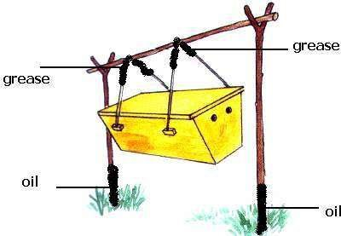

1. Put grease on the wires or strings used to hang the hive.
2. Put oil at the base of the poles.

Honey badgers

1. Honey badgers are small but strong animals.
2. They damage the hive, kill the bees and eat the honey.

Wax moths

1. These lay eggs in the combs.
2. The larvae of the wax moths make tunnels and spin grayish web in the combs which prevents the bees from getting through.
3. They also contaminate the hive with their waste.

MATTER AND ENERGY

MEASURESMENTS

The word measure means to find the size, amount, length, area and quantity of an object.

CAPACITY AND VOLUME.

CAPACITY.

1. Capacity is the amount of matter a container can hold.
2. Capacity of liquids is measured in liters.

Metric table for capacity of liquids

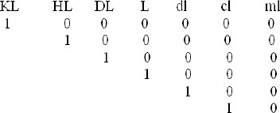

VOLUME.

1. Volume is the space occupied by a given object.
2. Volume is measured in cubic units e.g.

i. Cubic centimeters- cm3 or cc ii. Cubic millimeters – mm3iii. Cubic meters – m3

FINDING VOLUME OF REGULAR OBJECTS.

1. Regular objects are objects which have definite shapes.

e.g. cuboids, cubes.

Finding the volume of a cube or cuboid using cubes.

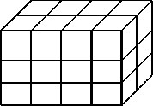

How many cubic blocks make up the above figure?

Finding the volume of a cube or cuboid using the formula.

Example I.

Find the volume of a cube whose side is 3cm.

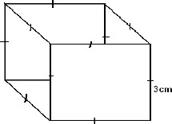Volume of a cube= Area of base x height.

= side x side x side.

= 3cm x 3cm x 3cm.

= 27cm3.

Note: A cube has all sides equal.

Example II.

Find the volume of the cuboid shown bellow.

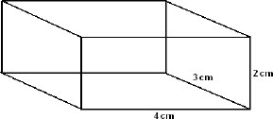Volume = area of base x height. = L x W x H

= 4cm x 3cm x 2cm

= 24cm3

Example III.

Find the volume of the figure shown bellow.

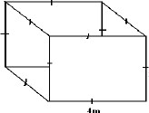

V = L x L x L

= 4m x 4m x 4m

= 84m3

EXERCISE

Find the volume of the following objects.

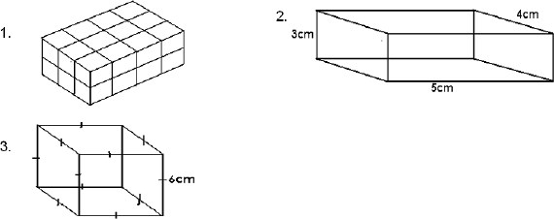

4. Find the volume of a rectangular block whose length is 6cm, width 4cm and height 3cm.

FINDING THE VOLUME OF IRREGULAR OBJECTS

1. Irregular objects are objects that don’t have definite shapes. E.g. stones.
2. The volume of irregular objects is measured using displacement method.
3. It is called the displacement method because the irregular object displaces water.
4. When an irregular object is fully immersed in water, it displaces the amount of water equal to its volume.

Things needed to help you find the volume of irregular objects.

1. Measuring cylinder.
2. Water.
3. An irregular object e.g. a stone.
4. An over flow can or eureka can.
5. String.

Steps taken when finding the volume of an irregular object using a measuring cylinder.

Step I

1. Pour water into a measuring cylinder so that it is about half full
2. Record the first volume of water. Say 30cc.

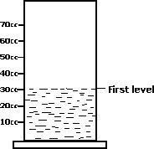

Step II

1. Get a stone tie it with a string.
2. Lower the object into the measuring cylinder so that the object is covered by water.
3. Record the volume of water again say 50 cc.

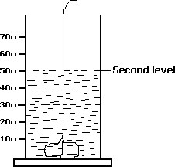

Volume of the stone will be equal to:

V = 2nd level- 1st level = 50cc- 30cc = 20cc.

The volume of the stone is 20cc because when an object is lowered in water, it displaces an amount of water equal to its volume.

EXERCISE:

An experiment was carried out by P.4 pupils to find the volume of the stone using a measuring cylinder as shown below.

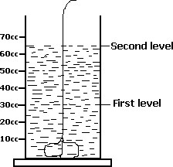

1. Calculate the volume of the stone.
2. Why is the volume of the stone equal to that answer you have given?

Finding the volumes of irregular objects using an over flow can

Step

I

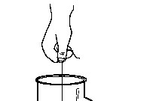

1. Fill the can with water so that the water pours out through the spout.( i.e. until it over flows).
2. When no more water pours out, then the water is up to the level of the hole or spout.

Step II

1. Lower an object whose volume you want to measure and lower it into the can.
2. The water will overflow and pour into the measuring cylinder.
3. Find the volume of the object by reading the level of water in the cylinder.

Note: When an object is lowered in water, it displaces an amount of water equal to its volume.

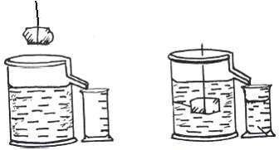

EXERCISE

1. A p.5 class carried out an experiment as shown in the diagram.

What was the volume of the stone?

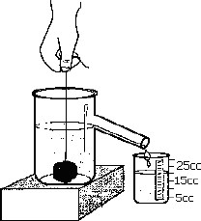

1. Find the volume of the stone in the experiment below.

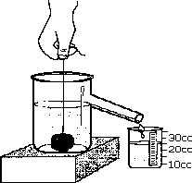

Displacement using regular objects.

1. Find the volume of water that will be displaced by the block as shown below.

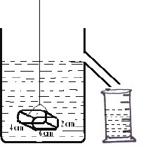

1. What volume of water will be displaced if the block below is immersed in the water?

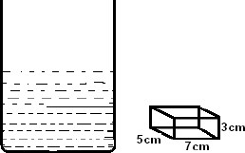

1. What will be the level of water if the object is removed from the measuring cylinder?

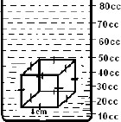

1. What will be the level of water if the object is put into the measuring cylinder?

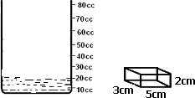

MASS

1. Mass is the amount of matter in an object.
2. The basic unit of measuring mass is kilograms(kg)

WEIGHT

1. Weight is the force caused by gravity of the earth pulling on a mass.
2. Weight is measured in Newtons (N).
3. Gravity is the pull of the earth on objects towards its centre.
4. Force is a push or pull, which makes objects stop or move.
5. Force makes moving things speedy, slow down, stop or change direction.

Machines used to measure weight. a. Beam balance.

* 1. Spring balance
  2. Set of scales.
  3. Scale balance.

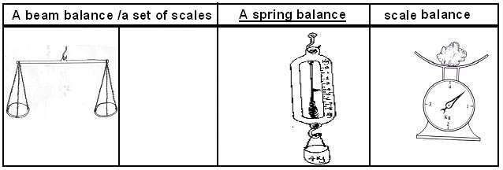

DIFFERENCES BETWEEN WEIGHT AND MASS

|  |  |
| --- | --- |
| MASS | WEIGHT |
| Measured in kilogram | Measured in Newton (N) |
| Mass does not change | Weight changes |
| Mass is the amount of matter in a body. | Weight is the pull of the earth on an object. |

Density.

1. Density is the mass of an object per unit volume.
2. Density is measured in g/cc.
3. Density is mass over volume. (Density = mass/volume)

FINDING MASS, VOLUME AND DENSITY OF OBJECTS.

MASS.



Examples

1. Find the mass of an object whose volume is 5cc and density of 10g/ cc.

Volume = 5cc Density = 10g/cc

Mass = ?g

Mass = Density x Volume

* 1. = 10x 5

M = 50g

1. Work out the mass of an object whose volume is 3cm and density of 5g/cc

Volume = 3cc

Density = 5g/cc

Mass = ?g

Mass = Density x Volume

* 1. = 5x 3

M =15g.

Exercise

1. What is the mass of an object whose density is 10g/cc and volume of 6cc?
2. Find the mass of a stone whose density is 20 g/cc and volume of 5cc.

DENSITY

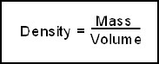

Examples

1. What is the density of an object whose mass is 14g and volume 7cc

Mass = 14g

Volume = 7cc

Density = ?g/cc

Density = mass/ volume

D = 14/7 D = 2g/cc.

1. Find the density of an object whose mass is 20g and volume 5cc.

Mass = 20g

Volume = 5cc.

Density = ?g/cc

Density = Mass/ volume

Density = 20/5 Density = 4g/cc.

EXERCISE

1. What is the density of an object whose mass is 30g and volume 5 cc.
2. Work out the density of an object whose mass is 24g and volume 6cc.
3. What is the density of an object whose mass is 10g and volume 5cc.
4. Find the density of the object below whose mass is 48g.

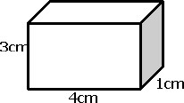

1. Work out the density of an object whose mass is 50g and volume 5cc.

VOLUME.

Examples.

1. What is the volume of an object whose mass is 14g and density2g/cc

Mass = 14g

Density = 2g/cc

Volume = ?cc

Volume = mass/density. = 14g/2g/cc = 7cc.

1. Work out the volume of an object whose mass is 15g and density of 5g/cc

Mass = 15g

Density = 5g/cc

Volume = ?cc Volume = mass/density.

= 15g/5g/cc.

Volume = 3cc.

EXERCISE

1. What is the volume of an object whose mass is 30g and density 6g/cc.
2. Work out the volume of an object whose mass is 24g and density 3g/cc.
3. What is the volume of an object whose density is 2g/cc and mass 10g.

FLOATING AND SINKING.

FLOATING

1. Floating is when an object stays on top (the surface).of the liquid on which it is put.
2. Objects float because they are less dense than water/liquid in which it put.

Note: When an object floats on water, it displaces the amount of water equal to its weight.

SINKING

1. Sinking is when an object goes down to the bottom of the container of the liquid it is put.
2. Objects sink because they are more dense than water/liquid in which it is put.

|  |  |
| --- | --- |
| Floating Objects | Sinking objects. |
| A pencil | A nail. |
| A leaf | A stone |
| A piece of paper | A coin |
| A bottle top. | Knife |
| A piece of wood | A set of rubbers |
| A toothbrush. | A key |
| A plastic mug/plate. | A button. |
| A piece of cork | A padlock |
| A rubber band | A pin |
| Boats | Sand |
| Ships etc. | Soil |
|  | A glass, etc |

1. When objects are dropped in water, there is always a force, which tends to push them upwards.
2. This force is called up thrust or buoyancy.
3. Up thrust is the upward force in water, which tends to push objects upwards.
4. Up thrust force make objects weigh less in water.

IMMUNITY AND IMMUNISATION

Immunity is the bodies’ ability to resist diseases.

Types of Immunity: a. Natural Immunity

b. Artificial Immunity

Ways of acquiring natural immunity a. After recovering from sickness.

* 1. From mother to child during pregnancy.
  2. From mother to child during breast feeding.

Ways of acquiring artificial immunity

Artificial immunity can be acquire through immunization (vaccination)

What is immunization?

Immunization is the introduction of vaccines into the body to make it produce antibodies against certain disease.

WHAT ARE VACCINES?

1. Vaccines are medical substances which are introduced in the body to make it produce antibodies against certain diseases.
2. Vaccines are made from killed or weakened germs.
3. The word immunization means the same as vaccination or inoculation.

STORAGE OF VACCINES

Vaccines are stored in cold-chain box (coolers).

Note. Vaccines are kept in cool containers to keep the germs dormant.

THE INFANT IMMUNISABLE DISEASES

They are eight childhood immunisable diseases.

They attack mostly children below the age of six years because their immunity against those diseases is still weak.

The immunisable diseases include the following: a. Measles

* 1. Polio
  2. Whooping cough
  3. Tuberculosis
  4. Tetanus
  5. Hepatitis B
  6. Diphtheria
  7. Haemophili influenza B.

MEASLES

It is caused by a virus spread from one infected person to another through air.

Signs and symptoms of measles a. High Fever

* + 1. Red eyes
    2. Sore mouth
    3. Rash all over the body
    4. Dry cough
    5. Runny nose

Prevention and control of measles:

* 1. Immunization with the measles vaccine.
  2. Isolation of the infected one.

Note: The measles vaccine is given at 9 months and not before. This is because the child is born with immunity against measles that lasts up to around 9 months.

TUBERCULOSIS (TB)

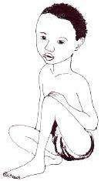

* 1. It is caused by bacteria.
  2. Tuberculosis is abbreviated as TB

How TB spreads

* 1. The bacterium which causes tuberculosis of the lungs spread by droplet infection through air.
  2. The infected person coughs and the germs are carried by air to another health person.
  3. The bacterium which causes tuberculosis of the alimentary canal and the skeleton is spread through drinking unboiled milk from tubercular cows i.e. cows infected with tuberculosis.

Signs and symptoms of TB a. a. Persistent cough

* + 1. Loss of body weight
    2. Coughing and spiting mucus with blood stains
    3. Pain in bones, joints and backache
    4. Persistent fever
    5. Over sweating at night.

Prevention and control of TB

* 1. Immunization with BCG vaccine.
  2. Isolation of the infected ones
  3. Treatment of the infected ones in recognized hospitals

Note: BCG vaccine is given at birth because a child is born with no immunity against tuberculosis.

POLIOMYELITIS (POLIO)

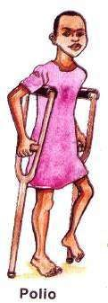

* 1. Polio is caused by a virus passed out by an infected person through faeces.
  2. The virus can be spread through drinking contaminated water.
  3. The disease affects the limbs.

Signs and symptoms of polio

* 1. Paralysis or weakness in one or more limbs
  2. Fever

Prevention and control of polio

* 1. Immunization with the polio vaccine.
  2. Boiling drinking water can also control polio.
  3. Putting all faeces in latrines.

TETANUS

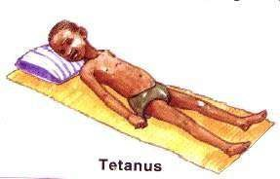

* 1. It is usually caused by bacteria found in the soil.
  2. The bacteria enter the body through fresh cuts or wounds.
  3. In newborn babies, it can enter through the umbilical cord if it is cut with a dirty or unsterilized instrument like razorblade.

Signs and symptoms of tetanus

* 1. Stiff muscles all over the body
  2. Spasms when touched
  3. The baby stops suckling the mother’s breast.

Prevention and control of tetanus

* 1. Immunization with DPT vaccine.
  2. Use sterilized cutting tool to cut the umbilical cord of babies.

Note: DPT vaccine is not given at birth because the baby is born with immunity against tetanus which lasts up to 6 weeks.

WHOOPING COUGH

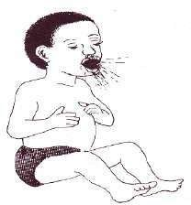

* 1. Whooping cough is also called pertussis.
  2. It is caused by bacteria and spread through air by coughing.

Signs and symptoms of whooping cough

* 1. Coughing spells which end in vomiting.
  2. Gasp for breath.
  3. Runny nose.

Prevention and control of whooping cough

* 1. Immunization with DPT vaccine.
  2. Isolation of the infected ones.

DIPHTHERIA

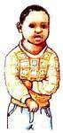

* 1. It is caused by bacteria spread through air.
  2. This disease is not very common.

Signs and symptoms

* 1. Sore throat.
  2. Swollen neck.

OTHER IMMUNISABLE DISEASES

Cholera

Cholera is an acute infectious disease caused by bacteria called vibro cholerae.

The incubation period of the disease is 3-6 days after infection and cholera kills with in 12 to 48 hours after the first sign if it is not treated very quickly.

How does cholera spread

* 1. Cholera spreads through drinking water contaminated with cholera germs.
  2. Cholera spreads through eating food contaminated with cholera germs.
  3. Cholera can also spread when a health person touches a sick person.

Signs and symptoms of cholera 1. Serious watery diarrhoea 2. Severe vomiting.

* 1. Cramps, shock and dehydration
  2. Weakness collapse and death

Prevention and control of cholera

* 1. Through immunization.
  2. Boiling drinking water.
  3. Cover all food to avoid houseflies.
  4. Take the infected patients to the hospital as soon as possible.
  5. Putting all faeces in a latrine.
  6. Wash hands before eating food and after using the latrine.
  7. Reheat left food.
  8. Give a lot of oral rehydration salts to prevent dehydration
  9. Observe good food hygiene.

Meningitis

* 1. It is caused by bacteria.
  2. The bacteria attacks the membrane which covers the brain called meninges.
  3. The bacteria are spread through air.

Yellow fever

* 1. Yellow fever is caused by a virus.
  2. It is spread by the aedes or tiger mosquito.
  3. Aedes mosquito is black with white spots on its body and wings.
  4. It bites during the day.
  5. Yellow fever causes yellowing of the eyes, palm and soles of our feet.

Small pox:

* 1. This disease has been eradicated from the world through constant immunization.
  2. This disease was caused by a virus and spread through air.

Typhoid

* 1. It is caused by bacteria called Salmonella typhi.
  2. Spread through contaminated water or food by a housefly.

Influenza

* 1. It is caused by a virus.
  2. It spreads through air.

Rubella (German measles)

* 1. It is caused by virus
  2. It is a highly infectious disease which causes a rush and fever.
  3. It usually affects older children and adolescents.

Typhus

* 1. It is caused by bacteria.
  2. It spreads when lice bite an infected person and then it bites a normal person.

Plague

* 1. It is caused by bacteria.
  2. It is spread by rat fleas.
  3. One should be immunized every after 6 months against it.

Rabies

* 1. It is serious disease caused by a virus.
  2. It affects the nervous system.
  3. The disease is spread by the bite of an infected dog or fox.

IMMUNISATION SITES AND SCHEDULE

|  |  |  |  |  |
| --- | --- | --- | --- | --- |
| AGE | VACCINE | DISEASE (S) | MODE OF  ADMINISTRATION | SITE |
| At birth | 1. BCG 2. Polio O | 1. Tuberculosis 2. Polio | 1. Injection 2. Drops. | 1. Right upper arm. 2. Mouth |
| 6 weeks | Polio | Polio | Drops. | a. Mouth. |
| DPT I | 1. Diphtheria 2. Whooping cough 3. Tetanus | Injection. | Left upper thigh. |
| Heb 1 | Hepatitis B | Injection. | Left upper thigh. |
| Hib 1 | Haemophilius  Influenza Type B | Injection. | Left upper thigh |
| 10 weeks | Polio II | Polio | Drops. | Mouth. |
| DPT II | 1. Diphtheria 2. Whooping cough 3. Tetanus | Injection. | Left upper thigh. |
| Heb 2 | Hepatitis B | Injection. | Left upper thigh |
| Hib 2 | Haemophilius  Influenza Type B | Injection. | Left Upper thigh |
| 14 weeks | Polio vaccine | Polio | Drops. | Mouth. |
| DPT III | 1. Diphtheria 2. Whooping cough 3. Tetanus | Injection. | Left upper thigh. |
| Heb 3 | Hepatitis B | Injection | Left upper thigh. |
| Hib 3 | Haemophilius  Influenza Type B | Injection | Left upper thigh. |
| At 9  months | 1. Measles vaccine 2. Vitamin A | 1. Measles 2. Blindness | 1. Injection. 2. Drops. | 1. Left upper arm 2. Mouth. |
| Girls and  Women between 15-49 years | Tetanus Toxoid  Vaccine  (TT vaccine) | Tetanus | Injection | Left upper arm. |
| Pregnant women | Tetanus Toxoid Vaccine (TT  vaccine) | Tetanus | Injection | Left upper arm. |

IMMUNISATION SITES

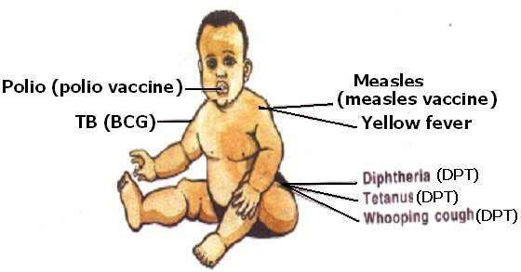

Importance of immunization

* 1. Immunization helps to protect children against the immunizable disease.
  2. Immunization helps to boost the immunity of the body.

1. Immunization reduces the rate at which children die before the age of eight years.
2. Immunization removes the fear that some children die and other survive so the parents only produce the number of children they want.

Importance of a child health card

1. It helps the parents to know when the next dose will be given.
2. It helps the parents to monitor the growth of their children
3. It provides information on the child’s name, sex, date of birth, birth order, mother’s name, mother’s occupation, father’s name, father’s occupation and where the family lives. Role of individuals, family and community in immunization service
4. Individuals inform other members of the group of the day of immunization.
5. Children who learn about immunization at school should take their young sisters or brothers for immunization.
6. Individuals can gather different members to organize immunization centre.
7. The family should make sure that all the young children are immunized on schedule.
8. Parents take their children for immunization.
9. Community members should organize a health committee that should organize, seminars, workshop, plays and drama about immunization.
10. Local councils mobilize community members to take their children for immunization.
11. Teachers create awareness about immunization.

Common abbreviation

1. UNEPI: Uganda National Expanded Program on Immunization.
2. NID: National Immunization Days.

# DIGESTIVE SYSTEM OF MAN

Digestion.

1. Digestion is the process by which food is broken down into simple soluble substances that can be absorbed in the blood stream.
2. Digestion begins from the mouth and ends in the ileum.
3. A digestive system is an alimentary canal with other associated organs like the liver and the pancreas
4. The tube running from the mouth to the anus is called an alimentary canal. Types of digestion
   1. Mechanical digestion
   2. Chemical digestion

Mechanical digestion

1. This is the process where food is broken down into small particles by the teeth.
2. It takes place in the mouth in human beings.

Chemical digestion.

1. This is the process where food is broken down by chemical substances called enzymes.
2. Chemical digestion starts in the mouth and ends in the ileum.

Enzymes.

1. Enzymes are chemical substances that speed up the rate of digestion.

Characteristics of enzymes.

1. They are destroyed by heating because they are protein in nature.
2. A particular group of enzymes always forms the same end product.
3. They are specific i.e. each enzyme acts upon particular class of food.
4. They act in particular conditions i.e. some prefer acidic, others alkaline conditions.

The digestive system.

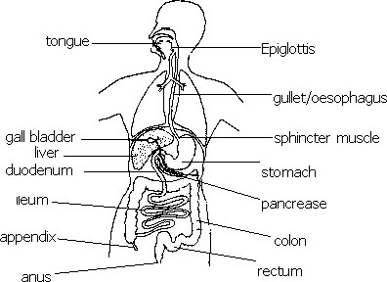

Functions of different parts.

The teeth:

Break food in smaller particles hence increasing the surface area for the action of enzymes.

The salivary glands:

Produce saliva.

The tongue:

1. tastes food.
2. rolls the food into a bolus.
3. pushes food into the gullet.

The epiglottis:

Prevents foreign particles from entering the trachea.

The soft palate:

Prevents food from entering the nasal cavity.

The stomach:

1. Temporary store for food.
2. Produces gastric juice.
3. Produces hydrochloric acid.
4. Absorbs alcohol.
5. Churns food into chyme.

The liver:

Produces bile.

The pyloric sphincter:

It is a strong muscle which holds food into the stomach and lets it into the duodenum at intervals.

The gull bladder:

Stores bile.

Bile duct

Conducts bile into the duodenum.

The pancreas:

Produces pancreatic juice.

Pancreatic duct

Conducts pancreatic juice into the duodenum.

The ileum:

1. Produces intestinal juice.
2. Final digestion of food takes place here.
3. Absorption of digested food takes place here. Colon:

Absorbs water from the undigested food.

Rectum:

Temporary store for undigested food.

Anus:

Passes out the undigested food as faeces.

Peristalsis.

1. Peristalsis is the wave-like movement of food through the alimentary canal.

Illustration of peristalsis.

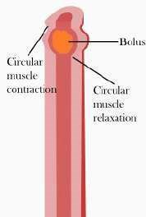

Digestion in the mouth.

1. In the mouth, food is chewed and mixed with saliva.
2. Saliva is produced by the salivary glands in the mouth.
3. Chewing increases the surface area for the action of enzymes and simplifies swallowing.

Factors that stimulate the production of saliva.

* 1. smell of the food.
  2. sight of food.
  3. taste of food.
  4. expectation for the food.

Functions of saliva.

* 1. Softens food.
  2. Lubricate food for easy swallowing.
  3. Contains an enzyme called salivary amylase (ptyalin) that acts upon cooked starch.

Note: The conditions in the mouth is alkaline.

Digestion in the stomach:

1. The movement of muscles of the stomach churn the food into a semi-liquid substance called chyme.
2. The stomach walls also secret( produce) gastric juice and hydrochloric acid.
3. Gastric juice contains two enzymes namely;
   1. pepsin.
   2. rennin.
4. Pepsin acts upon proteins to peptides.
5. Rennin acts upon the milk protein. Functions of hydrochloric acid.
   1. Stops the action of the salivary amylase.
   2. Activates pepsinogen to pepsin
   3. Provides suitable acidic conditions in which pepsin works best.
   4. Kills the bacteria which may have been taken in with the food.
6. When digestion in the stomach is complete, the pyloric sphincter relaxes at intervals to let chyme into the first part of the small intestine called duodenum.

Note: Digestion of carbohydrates does not take place in the stomach because the acidic conditions stop the action of salivary amylase.

Digestion in the duodenum.

1. An alkaline juice (pancreatic juice) is poured in to the duodenum by the pancreas through the pancreatic duct.
2. Pancreatic juice contains enzymes like;
   1. Trypsin: which breaks down proteins to peptides and peptides to amino acids.
   2. Pancreatic amylase: which breaks down uncooked starch to maltose.
   3. Lipase: which breaks down fats to fatty acids and glycerol.
3. Pancreatic juice also contains sodium hydrogen carbonate salts that neutralise hydrochloric acid.
4. Bile is a green fluid produced by the liver, stored in the gull bladder and conducted into the duodenum by the bile duct.
5. Bile contains bile salts that emulsify (breakdown) fats.

Digestion in the ileum.

1. The ileum secretes an intestinal juice called succus entericus which contains enzymes like;
   1. Peptidase: breaks down peptides to amino acids.
   2. Lipase: breaks down fats to fatty acids and glycerol.
   3. Maltase: breaks down maltose to glucose.
   4. Sucrase: breaks down sucrose to glucose and fructose.
   5. Lactase: acts upon lactose to glucose and galactose.
2. The ileum also produces mucus, which lubricates the food passage and prevents enzymes from digesting the walls of the ileum.

Absorption in the ileum.

1. Absorption of digested food takes place in the ileum.
2. This takes place with the help of the finger-like structures called villi.

Adaptation of the ileum to absorption of digested food.

1. The ileum is fairly long so, it provides a larger surface area for absorption.
2. It has villi, which also help to increase the surface area for absorption of digested food.

An illustration of an ileum.

**Adaptation of the villi to**

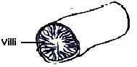

**Ab**sorption of digested food.

1. The wall of each villus is one cell thick and this makes it possible for digested food to pass through it easily.
2. Each villus has a dense capillary network, which facilitates absorption of digested food.

An illustration of a villus.

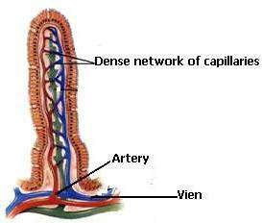

|  |  |
| --- | --- |
|  | Processes that take place in the ileum. a) digestion of food.  b) absorption of digested food. |

The colon and the rectum

1. Digestion does not take place in the colon and the rectum because they do not secrete enzymes.
2. The major process that takes place in the colon is absorption of water from the undigested food.
3. The undigested material is sent down to the rectum where it is temporarily stored till it is ready to be passed out.
4. It's later passed out as faeces through the anus.
5. The passing out of the undigested food from the alimentary canal is called egestion.

Summery of the food class and its end product.

|  |  |
| --- | --- |
| Food class | End product |
| Carbohydrates | glucose |
| Fats | fatty acids and glycerol |
| Proteins | amino acids |

How digested food is used in the body.

1. Glucose:
   1. used to generate energy through respiration.
   2. used to generate body heat through respiration.

1. Amino acids:
   1. are re-assembled to form proteins used to make new body cells for one to grow.
   2. are re-assembled to form proteins used to repair worn out tissues.
2. Fats:
   1. used to generate energy and heat.
   2. acts as a body insulator.

Note: Twice as much energy is obtained from fats than glucose.

1. Vitamins and mineral salts:

Keep us healthy so, they act as protective foods.

Some important mineral salts needed by our bodies. Iron:

1. Found in meat, liver, iron tablets, beans, peas egg yolk and green vegetables.
2. It's necessary for the manufacture of red blood cells.
3. Shortage of iron in the diet leads to anaemia.

Other factors that lead to anaemia. a) Severe bleeding.

* 1. Severe hookworm infestation.
  2. Destruction of the red blood cells by plasmodia parasite that causes malaria.
  3. Failure of the red bone marrow to manufacture red blood cells.

How the problem of anaemia is solved in patients. a) Eating foods rich in iron.

* 1. Through blood transfusion.
  2. Taking iron tablets.

Iodine:

1. Found in iodised salt and seafood like crabs, sea fish etc.
2. It's necessary for proper functioning of the thyroid gland.
3. Its deficiency leads to goitre.

Calcium and phosphorus.

1. Present in the milk and hard water.
2. They are necessary for the formation of strong bones.
3. Their deficiency leads to the formation of weak bones.

Some important vitamins for our bodies. Vitamin A:

1. Found in milk, green vegetables, liver, pepper, carrots, pawpaw, tomatoes palm oil etc.
2. It's necessary for good eyesight.
3. Its deficiency leads to poor night vision.

Vitamin B1:

1. Contained in yeast, ground nuts and unpolished rice.
2. Necessary for the prevention of beriberi.
3. Its deficiency leads to beriberi.

Other vitamins

Vitamin B2:

1. Found in yeast, groundnuts, yams, milk, meat and egg yolk.
2. Their deficiency leads to pellagra.

Vitamin C:

1. Found in oranges, lemon, row mangoes, guava, pawpaws and green vegetables.
2. Necessary for the prevention of scurvy.
3. Its deficiency leads to scurvy.

Vitamin D:

1. Contained in milk, egg yolk, fish liver oil etc.
2. Necessary for the prevention of rickets.
3. Its deficiency leads to rickets.

Vitamin E:

1. Present in green vegetables, butter, eggs, grains and nuts.
2. Necessary for reproduction.
3. Its deficiency leads to the poor formation of reproductive cells.

Vitamin K:

1. Present in green vegetable especially cabbage and spinach.
2. Essential for blood clotting.
3. Its deficiency leads to poor blood clotting.

Diseases of the digestive system: a) Stomach Ulcers

* 1. Appendicitis
  2. Cholera
  3. Dysentery
  4. Diarrhoea

Disorders of the digestive system:

Constipation:

1. This is a condition where one passes out faeces with difficulty or fails to pass out faeces at all.
2. It is prevented by;
   1. including roughage in the diet.
   2. taking enough water after meals.

1. Sources of roughage.
   1. Pineapple.
   2. Mangoes.
   3. Green vegetables.
   4. Cereals.

Intestinal obstruction:

Solved through surgical operation.

Vomiting:

1. Vomiting usually occur when there is stomach irritation.
2. It can also occur as a result of stomach infection (food poisoning).

Indigestion

It is a condition where food fails to get digested properly.

Causes of indigestion.

* + 1. Over eating where the stomach is full and fails to churn the food.
    2. Taking big lamps of food without proper chewing.

**P.5 SCIENCE LESSON NOTES**

**TERM II**

COMPONENTS OF THE ENVIRONMENT

SOIL

Soil is a medium in which plant grow.

Processes by which soil is formed a. a. Weathering

b. Decomposition.

Weathering

This is the breaking down of rocks into soil particles.

Decomposition

Decomposition means breaking down of organic matter into humus.

COMPOSITION OF SOIL (COMPONENTS OF SOIL) a. a. Water.



a. Air.

* + 1. Humus (organic matter)
    2. Rock particles.
    3. Dissolved mineral salts.
    4. Living organisms. eg bacteria

Inorganic matter

These are rock particles and mineral salts.

Organic matter

1. Humus is formed after animals and plant remains have decayed.
2. The bacteria which help in the decaying/decomposition are called putrefying bacteria.
3. Humus helps to hold soil particles together and also balance soil temperature.
4. Humus adds nutrients to the soil.
5. Humus gives the soil a dark colour which helps it to absorb heat from the sun.

Water

1. Water is important in the soil because it dissolves many soluble minerals to form solutions which plants take in easily by osmosis.
2. Water is a very important raw material during photosynthesis.
3. Soil without water becomes dry, light and unproductive.

An experiment to show that soil contains water or moisture.

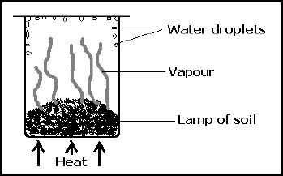

1. Get a lump of soil and put it in a beaker.
2. Put the beaker on fire and heat while covering the beaker as above.

Observation

Water droplets were seen on the sides of the beaker.

Conclusion

Soil contains water.

AIR

1. Air is found in spaces between soil particles called pore spaces.
2. The air in soil is important for root respiration and allowing living organisms in the soil to continue living.
3. Plant roots need fresh air around them otherwise without fresh air, the roots rot and make the plant die.
4. Aeration of soil is the addition of air to the soil by creating more pore spaces.
5. Earthworms, ants, termites etc help to aerate soil by making small holes in the soil.

An experiment to show that soil contains air

1. Get water in a container/beaker.
2. Get a lump of soil and lower it in a container with water as shown below.

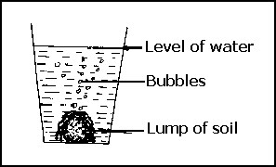

Observation

Bubbles of air are seen coming out of the soil.

Conclusion

Soil contains air.

LIVING ORGANISMS

1. Examples of living organisms in soil.
   1. Bacteria
   2. Fungi
2. Bacteria and fungi help in decomposition of organic matter.

DISSOLVED MINERAL SALTS.

1. These are mineral salts found in the soil but can dissolve in water to form plant food in form of solutions.
2. Plant roots use the process of osmosis to absorb the mineral salt solutions.

Examples of mineral needed by plants. Potassium:

This helps the plant to build resistance to diseases and drought.

Calcium:

This helps to strengthen the plant stem and leaves.

Phosphorus:

This is needed for the formation of strong plant cell wall.

Nitrates and phosphates:

Plants get nitrogen from nitrates which combines with phosphates to make plant proteins.

Magnesium and iron:

These are responsible for the formation of chlorophyll.

TYPES OF SOIL

1. Loam soil.
2. Clay soil.
3. Sand soil.

Loam soil.

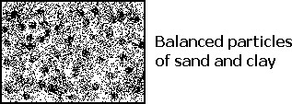

1. It contains balanced particles of sand and clay.
2. It contains more humus than clay and sand.
3. Well drained.
4. Well aerated.

Clay soil.

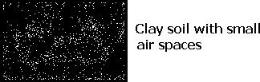

1. It is poorly drained because it has tiny air spaces.
2. It has fine particles.
3. It is difficult to plough because it is sticky when wet.
4. It has the highest rate of capillarity.
5. It is poorly aerated because of small air spaces.
6. .

Note: Clay soil is suitable for pottery i.e. making cups, plates teapots flower vases etc because it is sticky when wet.

Sand soil.

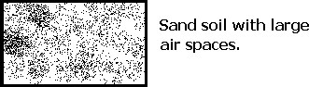

1. It allows water to go through it easily because it has wider air spaces.
2. It has poor rate of capillarity.
3. It is well aerated because of large air spaces
4. 4. It dries out quickly.

5. It has little plant nutrients.

An experiment to find out the permeability or drainage of water through different types of soil.

a. Place a filter paper in each of the three funnels.

1. Half fill the funnels with equal volumes of dry clay, sand and loamsoil.
2. Place them on glass jars as shown below.
3. Pour an equal amount of water in each funnel.

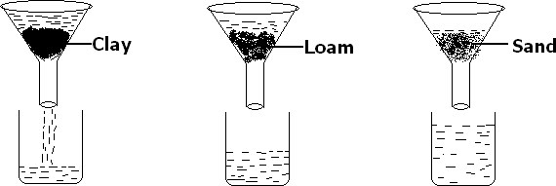

Observation

After sometime, more water was collected in the jar containing sand followed by loam and little water in clay.

Conclusion

Sand is more permeable than any other type of soil or sand allows water to pass through it easily because it has wide air spaces (pores)

An experiment to find out capillarity of different types of soil.

1. Fill three glass tubes (with open ends) with tightly packed sand, clay and loam soils.
2. Put the lower ends of the test tubes with cotton wool.
3. Place the tubes in about 3cm of water in a trough or basin as shown below.

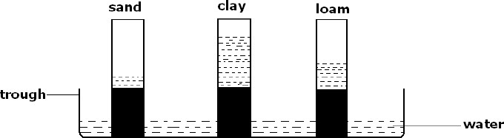

Observation

1. After a few hours, we found that water has risen through soils in each tube.
2. Water rises to the greatest height in clay soil, medium height in loam soil and to the lowest height in sand.

Conclusion

Clay soil has the greatest rate of capillarity or capillary action than sand and loam soils.

Importance of soil to plants

1. Soil holds water for plants.
2. Soil contains air which is needed by plants roots.
3. Soil holds plants firmly in the ground.
4. Provides nutrients to the plants.

Importance of soil to man

1. Crop growing.
2. Material for building houses.
3. Source of income. (sand mining).
4. Making crafts (pottery and models)

SOIL EROSION

Soil erosion is the removal of topsoil.

Agents of soil erosion.

Agents of soil erosion are things that help in removing topsoil. These are:

* 1. Wind.
  2. Running water.
  3. Man.
  4. Animals.

Causes of soil erosion

a. Mono cropping

* 1. Deforestation
  2. Overgrazing
  3. Bush burning
  4. Over cultivation
  5. Over stocking.
  6. Shifting cultivation.

Types of soil erosion a. a. Splash erosion



* 1. Rill erosion
  2. Sheet erosion
  3. Gully erosion

Splash erosion

1. Splash erosion occurs when raindrops hit the bare ground and splash the soil particles from their original position.
2. Splash erosion is also known as raindrop erosion.

Diagrams showing splash erosion

Rain droplets hit the ground and the soil splashed

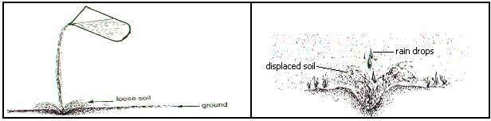

Rill erosion

1. Rill erosion occurs when running water forms rills on the ground.
2. As the water continues to flow along its path, it removes the topsoil.

Sheet erosion

1. Sheet erosion occurs when the soil which is bare on the ground is removed uniformly.
2. Sheet erosion may also be called overland erosion. A diagram showing sheet erosion

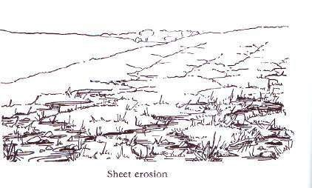

Gully erosion

1. When running water continues removing the soil, the channel deepens and widens.
2. The channels formed are called gullies.
3. It is difficult to plough across a gully.

Methods of controlling soil erosion

* 1. Mulching
  2. Crop rotation.
  3. Planting windbreaks.
  4. Contour ploughing.
  5. Terracing
  6. Inter cropping
  7. Agro-forestry
  8. Cover cropping.
  9. Strip cropping.

Mulching

1. Mulching is the covering of soil with dry plant materials.
2. Plant materials that can be used include:
   1. Dry maize plants.
   2. Dry grass.
   3. Dry leaves.
   4. Coffee husks.
   5. Wood shavings.
3. Mulching controls soil erosion by reducing the strength of the raindrops.

Other uses/importance of mulching

a. To conserve soil moisture.

* 1. To control weeds.
  2. To improve on the soil fertility.

Contour ploughing

1. This is the ploughing of the land across the slope.
2. Grass and crops are planted in alternate rows along the slopes, this helps to reduce the speed of running water.

Note: Ploughing up hill or down hill encourages soil erosion.

Crop rotation

1. This is the growing of different crops on the same piece of land seasonally.

Other importance of crop rotation

1. Controlling pests.
2. Controlling crop diseases.
3. Maintains soil fertility.

d. Control parasitic weeds.

Inter cropping

1. This is a practice of growing two or more crops in the same plot at the same season. eg planting beans between rows of perennial crops like banana, coffee etc.
2. These plants provide cover for the soil, thus reducing soil erosion.
3. Inter-cropping provides extra vegetation cover. This helps to reduce the growth of weeds.
4. Legumes are particularly important because they have bacteria that fix nitrogen in the

soil.

1. This makes the soil more fertile.

Agro-forestry

1. This is a method of planting trees with crops on the same piece of land.
2. These trees may be fruits bearing trees or trees that improve soil fertility.
3. In this method of farming, the trees act as windbreaks thus reducing soil erosion.

SOIL CONSERVATION

1. It is the maintenance of soil fertility.
2. When soil is not looked after properly, it can lead to soil exhaustion. Soil exhaustion

Soil exhaustion is the loss of soil fertility.

Causes of soil exhaustion:

i. Shifting cultivation.

ii. Mono cropping.

iii. Over cultivation.

iv. Leaching of mineral salts.

v. Soil erosion.

Leaching of mineral salts.

Leaching is the washing of mineral salts from the upper to the lower layers where plant roots can not reach.

Harmful materials in the soil.

1. Polythene.
2. Metal scrap material.
3. Glass.
4. Chemicals.
5. Debris.
6. Oil.

Effects of the harmful materials in soil.

1. Leads to soil pollution. eg oil, chemicals.
2. Polythene prevents water from sinking into the soil.

SOIL FERTILITY

Soil fertility is the ability of soil to support plant growth.

Ways of improving soil fertility a. By mulching.



1. Practicing crop rotation.
2. Bush fallowing.
3. Agro forestry.
4. Inter cropping legumes with other crops.
5. Adding fertilizers into the soil.

FERTILIZERS

There are two groups of fertilizers:

a. Natural fertilizers (manure).

b. Artificial fertilizers.

NATURAL FERTILIZERS (MANURE)

1. These are called organic fertilizers because they are made from plants and animals remains.
2. Examples of Natural fertilizers(manure). a . Farmyard manure.

b. Compost manure.

c. Green manure.

FARMYARD MANURE.

1. This is the manure got from animal urine and dung from cattle, sheep goats, rabbits and poultry.
2. It is first put into a heap to rot or decay before it is put in a garden.

Note: Human faeces are not commonly used because they instead spread germs and worms which cause a number of diseases

COMPOST MANURE.

1. This is made from household refuse, weed plant remains and left over food.
2. These things are first put in a heap to rot before they are taken to the main garden.
3. Compost pit should have a concrete lining to prevent leaching of nutrients.

How to make a compost manure..

1. Collect home refuse into a pit measuring 1.2m x 1.2m x 1.2m.
2. When the material is about 15cm thick, spread soil over it.
3. Water the layer, but do not pour too much water.
4. Repeat the above steps 1 to 3 until the heap is 1.2m high.
5. We keep the soil moist to speed up the decaying process.
6. Do not walk over the heap because this will expel the air needed by the organisms responsible for the decomposition of the plant materials.
7. Turn over the heap after 14days.
8. Remove layer by layer and build into a new heap.
9. After another 14days, turn over again.
10. After another 2weeks, the manure will be ready.

GREEN MANURE

1. Green manure is made from crops such as peas, beans etc.
2. These crops are planted and later ploughed down into the soil at the early stage of flowering.
3. The ploughing of crops down into the soil is done using a tractor or ox-plough.
4. In the soil, crops rot and release the organic matter into the soil.
5. Organic matter contains things like potassium, phosphorus, sodium and nitrates.

ADVANTAGES OF NATURAL FERTILIZERS (MANURE)

1. They improve the soil texture.
2. They make the soil hold water.
3. They stay for a longer time in the soil.
4. They can locally be available.
5. They have balanced nutrients.
6. They are not poisonous.

DISADVANTAGES OF NATURAL FERTILIZERS (MANURE)

1. They smell badly.
2. They are tiresome to make.
3. Plant and animal matter may not be easily got in some areas.
4. They can be a source of weeds.
5. They are difficult to handle.
6. They may be a source of diseases.

ARTIFICIAL FERTILIZERS

1. These are fertilizers which are manufactured in factories.
2. The name of the fertilizers depends on the mineral contained in them as indicated below:
   1. Sulphate of ammonia
   2. Single super phosphate(SSP)
   3. Nitrogen phosphorus potassium (NPK)
   4. Calcium Ammonium Nitrate(CAN)
   5. Double Ammonium Phosphate(DAP)

ADVANTAGES OF ARTIFICIAL FERTILIZERS

1. They are quick in improving soil fertility.
2. They provide the needed mineral salts to plants without fail.
3. They contain the right nutrients in the correct quantity.
4. They are easy to handle.

DISADVANTAGES OF ARTIFICIAL FERTILIZERS

1. They are expensive to buy.
2. You may not know which type of fertilizers to use.
3. You may not know the quantity to apply.
4. Excessive use pollutes the soil. This kills some useful soil living organisms
5. They are applied at specific times only.

7. Artificial fertilizers may be washed into rivers and springs causing water pollution.

MATTER AND ENERGY

MATTER

1. Matter is anything that occupies space and has weight.

Properties of matter.

* 1. Matter has weight.
  2. Matter occupies space.
  3. It is neither created nor destroyed.

States of matter.

There are three states of matter: a. Solids.

* 1. Liquids.
  2. Gases.

1. Matter is made up of small particles called molecules. Molecules are held together by either cohesion or adhesion.

Cohesion:

Cohesion is the force of attraction between molecules of the same kind.

Adhesion:

Adhesion is the force of attraction between molecules of different kind.

Arrangement of molecules in different states of matter

1. Molecules in solids

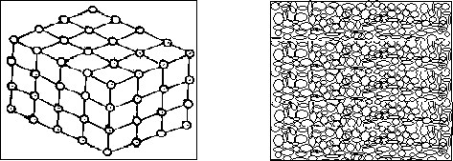

Characteristics of solids.

* 1. Molecules are closely packed together.
  2. Molecules do not move.
  3. They have definite shape.
  4. Heat travels through them by conduction.

1. Molecules in liquids

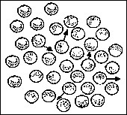

Characteristics of liquids.

* 1. The molecules are fairly spaced.
  2. Liquids take the shape of the container where they are put.
  3. Heat travels through liquids by convection.

1. Molecules in gase

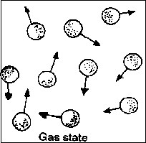

Characteristics of gases

* 1. The molecules are far apart.
  2. Have no shape.
  3. Heat travels through gases by convection.

Changes in states of matter

1. Changes in states of matter are as a result of heating and cooling.(change in temperature)
2. These changes include:
   1. Melting
   2. Evaporation
   3. Condensation
   4. Sublimation
   5. Freezing
   6. Deposition

1 Melting

1. Melting is the process through which solids change to liquids on heating.
2. When solids are heated, they change into liquids. eg. When ice is heated it melts to water.

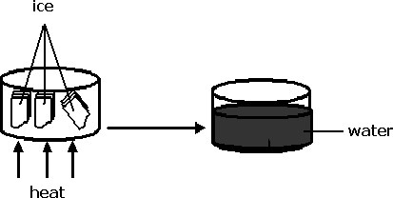

1. Evaporation
   1. Evaporation is the process through which liquids turn to gas on heating.
   2. When liquids are heated, they change to gas. e.g. water to water vapour or steam.

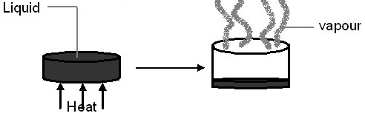

1. Freezing
   1. Freezing is the process through which liquids turn to solids on cooling.
   2. When water is frozen below O0C, they change to solids.

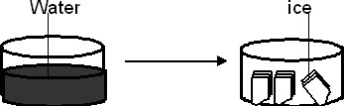

1. Condensation
   1. Condensation is the process through which gases turn back to liquids on cooling.
   2. When water vapour is cooled, it turns back to water.

1. Sublimation
   1. Sublimation is the process through which some substances change directly from solids to gas or gas to solids.
   2. Example of a substance that sublime are naphthalene and iodine crystals.

SUMMARY



SOLIDS



LIQUIDS



GASES

MIXTURES

1. What is a mixture?

A mixture is a combination of two or more different substances are combined together.

Examples of mixtures:

1. . mixture of sand and cement.
2. mixture of flour and water.
3. mixture of gases.
4. Mixture of water and salt.

Dissolving substances

When some substances are put in water or any other liquid and you stir, they disappear so we say they have dissolved. Therefore they are soluble in water or the liquid e.g a. Salt dissolves in water, so it is soluble in water.

b. Sugar dissolves in water, so sugar is soluble in water.

Note;

1. Such substances are called soluble substances.
2. All soluble substances are solutes.

A solute

1. A solute is a substance, which dissolve in solvent.

Examples of solutes: a. Salt.

1. Sugar.
2. Milk powder.

A solvent

1. A solvent is a liquid in which a solute dissolves.

Examples of solvents.

1. Water.
2. Petrol.
3. Methylated spirit.

Water as a universal solvent

1. Water is a universal solvent because it dissolves almost all solutes.
2. Substances, which do not dissolve in any liquid are called insoluble substances.

Examples of insoluble substances. a. Stones.

* 1. Sand.
  2. Maize flour.

A solution

A solution is a uniform mixture.

Examples of solutions

* 1. Salt solution
  2. Sugar solution
  3. Salt sugar solution
  4. Oral rehydration solution

METHODS OF SEPARATING MIXTURES a. Decanting

* 1. Filtration
  2. Crystallisation (evaporation to dryness )
  3. Distillation
  4. Sieving
  5. Floatation
  6. Using magnets
  7. Using a separating funnel
  8. Sorting ( hand picking)

SEPARATING MIXTURES OF LIQUIDS AND SOLIDS

Decanting

* 1. Decanting is a process of allowing the solid particles to settle at the bottom of the container and then carefully pouring off the clear liquid above.
  2. Decanting is used to separate solid particles from a liquid.
  3. In our daily life, decanting is used to get clear water from muddy water.

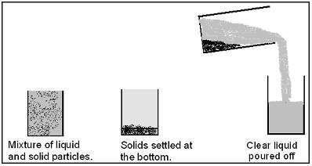

Filtration or filtering

* 1. It is the process of separating solid particles from a liquid using a filter.
  2. The solid particles remain on the filter and the clear liquid passes through the filter funnel.
  3. The solid particles are called the residue while the clear liquid is called the filtrate.
  4. Filtration is used at home to separate seeds from juice.
  5. Filtration can also be used to separate tea-leaves from tea solution.
  6. The filter paper is used to hold back solid particles.

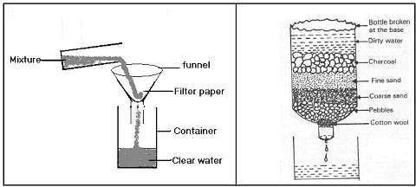

Crystallization (Evaporation).

* 1. Crystallization is the process in which solutes are recovered from their solutions.
  2. This is done by evaporating the solvent to dryness.
  3. This helps to in our homes to regain salt from salt solution.
  4. Recovering salt from a mixture of salt and sand.

Steps taken

* + 1. Collect the mixture in a container.
    2. Add water to the mixture and stir till the salt completely dissolves.
    3. Filter the solution to remove the sand particles.
    4. Heat the filtrate to dryness.

USING A SEPARATING FUNNEL

This is the method used to separate liquids that do not mix. (immiscible liquids).

Examples of liquids which do not mix. a. Water with cooking oil.

* 1. Water with petrol.
  2. Paraffin with water.

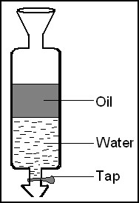

Note; These are liquids of different densities.

Distillation

1. Distillation is the process of separating liquids with different boiling points.
2. Example of these liquids; water and alcohol.
3. In daily life, distillation is used in the making of alcohol.

Flotation

This is a method used to separate a mixture of solids from where one is less dense than water eg

* 1. A mixture of sow dust and sand.
  2. A mixture of bad seeds and good seeds.

Using a magnet.

This is a method used to separate a mixture where one substance is magnetic and the other is non-magnetic.

picking

Sorting (Hand picking).

This is a method used to pick big particles from small particles in a mixture eg pieces of stone from rice, beans, soya before cooking.

Sieving.

This is a method used to separate large particles from small particles in a mixture using a sieve.

ENERGY

Energy is the ability to do work.

Types of energy

1. Kinetic energy.
2. Potential energy

Kinetic energy

Kinetic energy is energy possessed by moving objects.

Potential energy.

Potential energy is energy possessed by stationary objects.

Forms of energy.

1. Heat energy.
2. Electric energy.
3. Sound energy.
4. Magnetic energy.
5. Light energy.

HEAT ENERGY

1. Heat is a form of energy that brings about rise in temperature.

Sources of heat.

1. The sun
2. Fire
3. Friction
4. Electricity
5. Compression
6. Decomposition
7. Food

Note:

The sun is the main source of heat

Uses of heat

1. Heat enables us to cook food.
2. Heat enables us to be warm.
3. Heat is used to kill germs.
4. We use heat to iron clothes.
5. Heat helps in rain formation.
6. Heat is used to dry harvested crops before they are stored.

FUELS

1. Fuels are substances which produce heat or light energy when burnt.
2. Examples of fuels:
   1. Fire wood
   2. Charcoal
   3. Paraffin
   4. Petrol
   5. Diesel
   6. Wax
   7. Food

EFFECTS OF HEAT ON MATTER

1. Heat makes matter expand.
2. Heat causes rise in temperature of matter.
3. Heat causes change in states of matter.
4. Heat makes molecules in gases and liquids mobile.

EXPANSION IN GASES

Experiment I

* 1. Things needed:

i. Bottle ii. Balloon iii. Heat source

* 1. Tie a balloon on an empty bottle.
  2. Heat the bottom of the bottle as shown below.

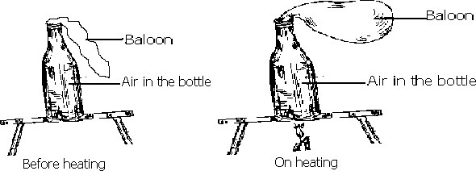

Observation

On heating, the balloon started swelling showing that the air inside the bottle is expanding.

Experiment II

Things needed:

1. Flask d. Water
2. Glass tube e. Stopper
3. Beaker f. Heat source

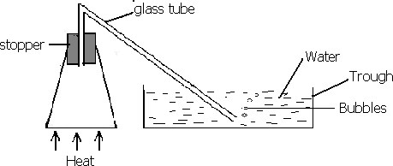

Observation

1. On heating, bubbles are seen escaping through the glass tube.
2. This shows that the air in the flask expanded on heating, thus escaping through the glass tube.

Experiment III Things needed: a. Flask

* 1. Stopper
  2. Glass tube.
  3. Heat source.
  4. Ink.

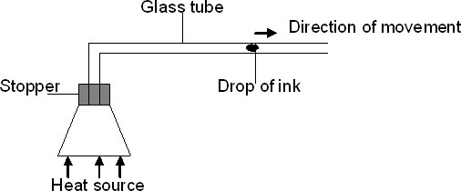

Observation

On heating, a drop of ink was seen moving away from the flask creating space for the expanding air in the flask.

Conclusion

Air expands when heated.

EXPANSION IN LIQUIDS Things needed:

a. Water b. Glass tube c. Stopper d. Test tube e. Heat source

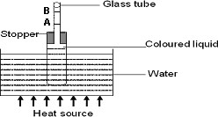

Observation

1. On heating, the water level rose from point A to point B.
2. This shows that water in the test tube expanded on heating.

NOTE: Water expands when cooled below 00C. That is why space is left in bottled liquids and foods.

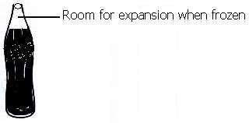

Note: the space left in bottled liquids is to give room for expansion.

EXPANSION IN SOLIDS

Bimetallic strip

1. This is a strip consisting of two metals with different expansion rates.
2. When such metals are heated, the metal with a higher expansion rate will bend over the one with low rate of expansion.
3. Bimetallic strips are used in thermostats.
4. A thermostat is a device that switches electric appliances on and off automatically.

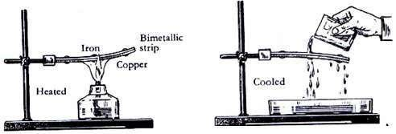

1. Examples of things that use thermostats:
   1. Car indicators.
   2. Electric flat irons.
   3. Refrigerators.
   4. Air conditioners.

EFFECTS OF EXPANSION OF SOLIDS

RAIL LINE TRACKS

1. During the construction of a railway line, gaps are left in between rails to give room for expansion on a hot day.

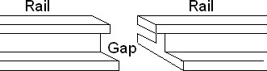

1. Gaps are narrow during a hot weather because the rails have expanded.
2. Gaps are wide during a cold weather because the rails have contracted.

Note: if the gaps are not left during construction, the railway may expand and bend.

EFFECTS OF CONTRACTION OF SOLIDS

TELEPHONE AND ELECTRICITY WIRES

During construction of telephone and electric lines, the wires are fixed loose to provide room for contraction on a cold day.

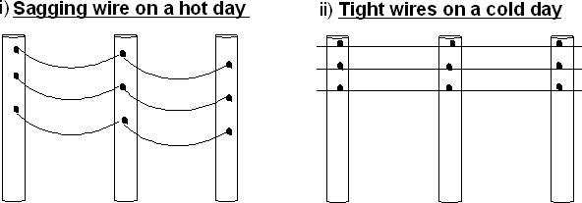

HEAT TRANSFER

There are three ways how heat moves from one place to another. a. Conduction

* 1. Convection
  2. Radiation

CONDUCTION

1. This is the process through which heat travels through solids.
2. When one molecule is heated, heat is passed to the next molecule until the whole solid becomes hot.

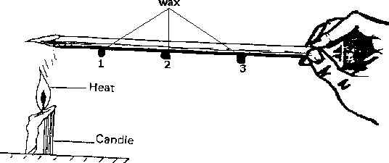

1. Wax marked number 1 melts first because it is nearest to the heat source.
2. Heat from the burning candle travels through the metal (nail) by conduction.

CONVECTION

This is the process by which heat travels through both liquids and gases.

Convection in liquids

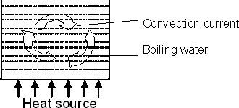

Convection in gases

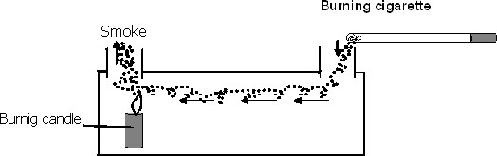

Application of convection

1.

Ventilation

Ventilation is circulation of air.

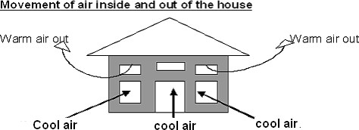

Importance of ventilation in a living house

1. Prevents suffocation
2. Prevents the spread of air borne diseases.

Movement of air inside and out of the Lantern

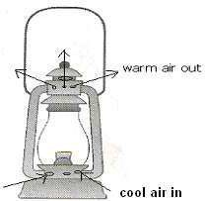

Movement of air inside and out of the Charcoal stove

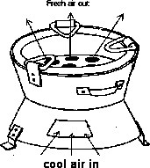

Movement of air inside and out of the charcoal box

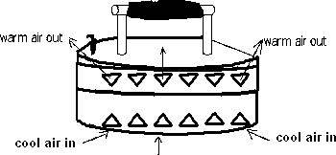

BREEZE

A breeze is cool gentle wind blowing from one place to another.

Types of breezes.

* 1. Land breeze.
  2. Sea breeze.

Land breeze

* 1. Land breeze is the movement of cool gentle wind from land to sea.
  2. It occurs in the night.
  3. In the night, the land loses heat faster than the water bodies.
  4. The air over the water body rises and cool air from the land blows towards the water body to replace the warm rising air.

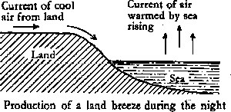

1. Sea breeze
   1. Sea breeze is the movement of cool gentle wind from sea to land.
   2. It occurs during the day time.
   3. During the day time the air over land gets heated faster than that over the water body.
   4. Air over land rises and the cool air from the sea moves to replace the warm rising air over the land.

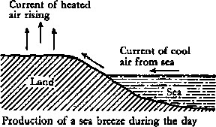

RADIATION

1. Radiation is the process by which heat travels through space.
2. Radiation does not require any medium of transmission.
3. This is why heat can pass through vacuum. A vacuum is space without matter.

Examples of radiation in nature

1. Heat from the sun reaches us by radiation.

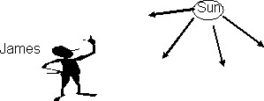

1. James is receiving heat from the sun by radiation.
2. When you stand or sit near a fireplace, you receive heat by radiation.

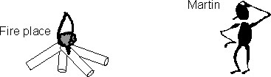

1. Martin is receiving heat from the fireplace by radiation.

SOLAR ENERGY.

1. The sun is the source of solar energy.
2. Solar energy can be converted into heat and electricity.
3. The heat rays from the sun are absorbed by solar panels.
4. The solar panel is put where the sun can shine. (Usually on top of a roof) 5. Solar panels are painted black to absorb light rays very easily.

CONDUCTORS OF HEAT

1. Conductors are materials that allow heat to pass through them.
2. Materials that allow heat to pass through by conduction are called good conductors of heat.
3. Examples of good conductors of heat:
   1. Iron g. Copper
   2. Steel h. Brass
   3. Silver i. Aluminium

Note: Silver is the best solid conductor of heat and mercury is the best liquid conductor of heat.

INSULATORS

1. Objects or substances that do not allow heat to pass through by conduction are called insulators.
2. Insulators are also referred to as poor or bad conductors of heat.
3. Examples of bad conductors of heat:

a. Plastic b. Wood

1. Rubb er
2. Wool
3. Asbestos k. Water

j. Air l. Glass

An experiment to prove that water is a bad conductor of heat Things needed:

* 1. Test tube c. Wax or Vaseline or ice.
  2. Water d. Heat source

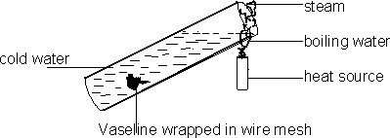

1. The water at the surface of the test tube will boil but the vaseline will not melt showing that water is a bad conductor of heat.
2. Vaseline is wrapped in wire mesh to keep it at the bottom of the test tube. Application of conductors and insulators

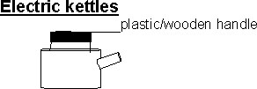

* 1. Handles of electric kettles are made out of wood or plastic because they are both bad conductors of heat.
  2. Elements of electric kettles are made from iron because iron is a good conductor of heat.

Electric flat irons



* 1. Handles of electric flat irons are made out of plastic because plastic is a bad conductor of heat.
  2. The ironing part of an electric flat iron is made from iron because iron is a good conductor of heat.

2

Charcoal box

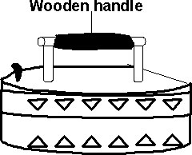

1. Handles of charcoal boxes are made out of wood because wood is a bad conductor of heat.
2. The ironing part of a charcoal box is made from iron because iron is a good conductor of heat.

Frying pans



* 1. Handles of frying pans are made out of plastic because plastic is a bad conductor of heat.
  2. The frying part of a frying pan is made from aluminium because it is a good conductor of heat.

REFLECTORS OF HEAT

* 1. Reflectors are objects that bounce heat and light.
  2. When heat falls on a shiny surface, it is reflected. Application of reflectors
  3. Most refrigerators are painted white to reflect most of the heat and remain cool inside.
  4. People in desert areas or hot areas usually wear white clothes to reflect heat.
  5. Most buildings are painted white so as to reflect heat and remain cool inside.
  6. Most vehicles are painted white to reflect heat.
  7. A Stevenson screen is painted white to reflect heat.

ABSORBERS OF HEAT

* 1. Absorbers are objects that do not bounce heat.
  2. When heat falls on a dull coloured surface, it is absorbed.
  3. Similarly, when heat falls on a rough surface, it is absorbed.
  4. A person wearing a black shirt feels hotter than the one wearing a white shirt on a hot day because black absorbs heat while white reflects heat.

THE THERMOS FLASK

* 1. A thermos flask is also known as a vacuum flask.
  2. The function of a vacuum flask is to keep hot things hot or cold things cold. Parts of a vacuum flask

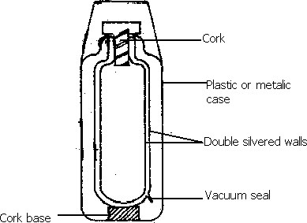

Functions of different parts of a vacuum flask

* 1. Cork
     1. cork prevents heat loss or gain by conduction because a cork is a bad conductor of heat.

* 1. Double silvered walls

The double silvered walls prevent heat loss or gain by radiation because they have a shiny colour (silver)

Vacuum

* + 1. vacuum prevents heat loss or gain by conduction and convection. a. By conduction because there is no molecule of solids.

b. By convection because there is no molecule of liquid or gas.

* 1. Cork base
     1. cork base supports the glass in position.

* 1. Plastic or metal case

The plastic or metal case protects the double walled glass.

* 1. Vacuum seal

Closes the vacuum.

TEMPERATURE

* 1. Temperature is the degree of hotness or coldness of a substance or place.
  2. Temperature is measured using a thermometer.
  3. Temperature is measured in degrees.
  4. Thermometers use either mercury or alcohol.

Differences between temperature and heat

|  |  |  |
| --- | --- | --- |
|  | Temperature | Heat |
| 1 | Is the degree of hotness or coldness of a substance or place. | Is a form of energy that brings about rise in temperature. |
| 2 | Measured in degrees. | Measured in joules  . |

Advantages of using mercury over alcohol

* 1. Mercury is a good conductor of heat and alcohol is a bad conductor of heat.
  2. Mercury does not stick on walls of a bore but alcohol sticks on the walls of a bore.
  3. Mercury is easily seen than alcohol.
  4. Mercury boils at a higher temperature compared to alcohol.

Advantages of using alcohol over mercury

* 1. Alcohol does not solidify easily.
  2. Alcohol is cheaper to buy compared to mercury.

Why water is not used in thermometers.

* 1. Water sticks on the walls of the bore.
  2. Water is a bad conductor of heat.
  3. Water has an irregular expansion.
  4. Water has a low boiling point.
  5. It is not easily seen.
  6. Water boils and freezes readily.

Types of temperature scales

There are two types of scales used in thermometers: a. Centigrade or Celsius scale.

b. Fahrenheit scale.

Centigrade or Celsius scale

* 1. The freezing point on this scale is 00C. The freezing point is also known as the lower fixed point.
  2. The boiling point on this scale is 1000C. The boiling point is also known as the upper fixed point.
  3. The freezing point (lower fixed point) is the temperature at which pure water changes to ice.
  4. The boiling point (upper fixed point) is the temperature at which pure water boils.

Fahrenheit scale

* 1. The freezing point on this scale is 320F.
  2. The boiling point on this scale is 2120F.

Note: The freezing point of water is 00C or 320F and boiling point is 1000C or 2120F.

TYPES OF THERMOMETERS

* + 1. Clinical thermometer or doctor’s thermometer.
    2. Six’s or maximum and minimum thermometer.

Clinical thermometer or doctor’s thermometer

* 1. It is used to measure human body temperature.
  2. The body temperature of a normal person is 370C or 98.40F.
  3. Places where a clinical thermometer is placed (put) to measure the human body temperature:
     1. In the anus. (for babies)
     2. Under the armpit.
     3. Under the tongue to avoid biting it.
     4. Vagina.

Note:

* + 1. The above parts are commonly used because they completely cover the bulb to give uniform expansion of mercury.
    2. Thermometers should be sterilized with alcohol every after use.
    3. Thermometers should not be stelirised using hot water because they break.

Features of a clinical thermometer

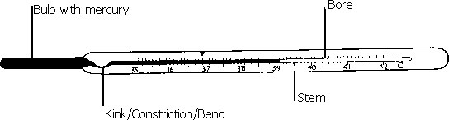

* 1. Kink/constriction/bend

It controls the back flow of mercury.

* 1. A stem/Glass envelope
     1. stem acts as a magnifying glass.
  2. Bore

The bore is very narrow to have an accurate scale.

* 1. The scale runs from 340C to 420C because the temperature of a living person is between 340C to 420C.

Note: A clinical thermometer should be shaken to force mercury back into the bulb before it is used again.

SIX’S OR MAXIMUM AND MINIMUM THERMOMETER

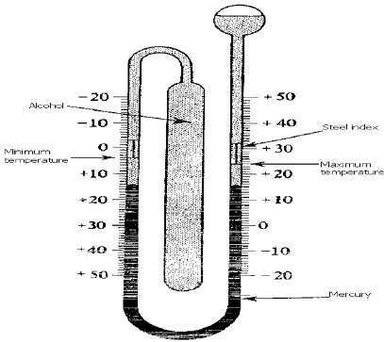

* 1. A six’s thermometer is used to measure both minimum and maximum temperatures.
  2. It uses both mercury and alcohol.
  3. The left hand side measures minimum temperatures and the right hand side measures maximum temperatures.
  4. A six’s thermometer uses indices.
  5. Readings are taken at the lower part of an index.
  6. Indices are re-set using a magnet.

Note: Mercury is used to measure maximum temperature because it has a high boiling point.

Alcohol is used to measure minimum temperature because it has a lower freezing point.

CONVERSION OF SCALES

Changing centigrade to Fahrenheit:

Formula: - 0F = (9/5 x C) + 32

Examples

a. Change 100C to 0F. b. Change 1000C to 0F.

0F = (9/5 x 0C) + 32 0F = (9/5 x 0C) + 32

= (9/5 x 0C) + 32 = (9/5 x 0C) + 32 = (9/5 x 10) + 32 = (9/5 x 100) + 32

2 20

= (9/5 x ~~10~~) + 32 = (9/5 x ~~100~~) + 32

1 1

= (9 x 2) + 32 = (9 x 20) + 32

= 18 + 32 = 180 + 32

= 50 = 212

100C = 50 0F. 1000C = 212 0F.

1. Change 400C to 0F. d. Change 150C to 0F.

0F = (9/5 x 0C) + 32 0F = (9/5 x 0C) + 32

= (9/5 x 0C) + 32 = (9/5 x 0C) + 32

= (9/5 x 40) + 32 = (9/5 x 15) + 32

3

= (9/5 x 40) + 32 = (9/5 x ~~15~~) + 32

1

= (9 x 40) + 32 = (9 x 3) + 32

5

= 72 + 32 = 27 + 32

= 104 = 59

400C = 104 0F. 150C = 59 0F.

Changing Fahrenheit to centigrade:

Formula: - 0C = 5/9 (F - 32)

Examples

a. Change 590F to 0C b. Change 320F to 0C

0C = 5/9 (0F - 32) 0C = 5/9 (0F - 32)

= 5/9 (59 - 32) = 5/9 (32 - 32)

= 5/9 x 27 = 5/9 x 0

3

= 5/9 x ~~27~~ = 0

1

= 5 x 3 320C = 0 0F.

= 15

590F = 15 0C.

BURNING

1. Burning is a chemical reaction in which heat and light are produced.
2. Regions (zones) in flames

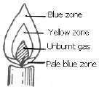

BLUE ZONE

1. It is the outer most region of the flame.
2. It receives good supply of air.
3. It is very difficult to see.

YELLOW ZONE

1. It consists of partly the unburnt gas.
2. It is the brightest part of the flame.
3. The yellow zone gives a lot of light.

CENTRAL ZONE (unburnt gas)

1. It does not burn because air can not reach it since it is deep inside the flame.
2. This zone does not give light.

PALE BLUE ZONE

1. It is at the bottom of the flame.
2. It receives a very good supply of air.
3. It is very hot.

An experiment which shows that oxygen supports burning Things needed:

i. Candle ii. Glass cup

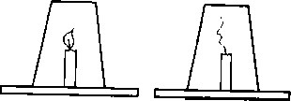

Observation

The candle flame continues burning for some time and later goes off.

Conclusion

The candle flame went off because oxygen in the glass cup got used up. Or the candle flame went off because the supply of oxygen was cut off.

Experiment II (oxygen is used up during burning)

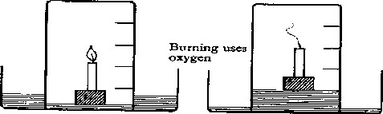

1. Take a bowl and half fill it with water.
2. Fix a small piece of candle to a wooden block and float the block on water.
3. Light the candle and place the jar over it as shown above.
4. The candle goes out after a short time because the oxygen in the jar is used-up.
5. You will notice that the water has risen in the jar and occupies the space which was formally occupied by oxygen.

PUTTING OUT FIRE

1. Putting out fire using a fire extinguisher.

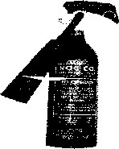

Carbondioxide is used in a fire extinguisher because it doesn’t support burning.

Putting out fire using sand.

Sand cuts off oxygen supply to the fire.

3. Putting out fire using a blanket.

When your clothes have caught fire, wrap yourself with a thick blanket.

The blanket cuts the supply of oxygen.

Reasons why water is not recommended for putting out electric and petrol fire a. Petrol floats on water and continues to burn.

b. Water is a good conductor of electricity so one can get severe shock.

Alternative method of putting out petrol fire

1. Using sand.
2. Use of foam. RUSTING
3. Rusting is the development of a brown coating on iron materials when they are in contact with oxygen and water.
4. This brown coating is called rust.
5. Condition needed for rusting to take place:
   1. Oxygen
   2. Moisture (water)

An experiment to find out that oxygen is used during rusting

1. Things needed to carry out this experiment:
   1. Iron filings b. Net bag

c. Jar d. Stick

e. Container with water

1. Steps taken.
   1. Moisten the iron filings and put them in a net-bag.
   2. Tie the net-bag on a stick and place it in a jar.
   3. Invert the jar in the container where there is water.

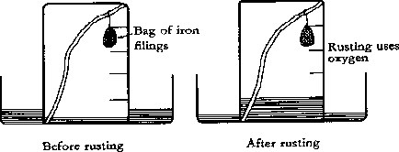

Observation

1. After a few days, the iron filings turned brown
2. The water level rose up in the glass jar.

Conclusion

The water level rose up in the glass jar to replace oxygen that was used during rusting. Advantage of rusting

1. Rusting helps to reduce metal scraps in the environment.
2. Improves soil fertility.

Disadvantages of rusting

1. Rusting results into wearing away of iron and steel equipment.
2. Nuts on bolts become hard to unscrew after rusting.

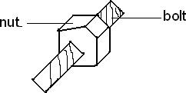

1. Water in rusty pipes and containers becomes polluted.
2. Keys fail to fit in padlocks after rusting.
3. Rust weakens useful iron materials.
4. Cutting materials become blunt after rusting.

Ways of preventing rusting

1. Oiling/greasing.
2. Painting.
3. Galvanising (coating iron with zinc) 4. Enameling (coating iron with enamel)

5. Making alloys.

AN ALLOY

1. An alloy is a mixture of two or more metals.

Examples of alloys:

* + - 1. Iron + carbon = steel.
      2. Copper + zinc = brass.
      3. Copper + tin = bronze

Similarities between rusting and burning

* 1. Oxygen is used in both processes.
  2. They are both chemical changes.

Differences between rusting and burning

* 1. Burning produces carbondioxide while rusting does not produce any gas.
  2. Burning requires only oxygen but rusting requires both water and oxygen.

CROP GROWING

Common tuber crops.

a. Root tubers

b. Stem tubers.

Root tubers

Root tubers are crops that store food in their roots

Examples of root tubers a. Cassava crops

* + - 1. Sweet potato crops
      2. Carrot crops.
      3. Turnip crops.
      4. Sugar beet

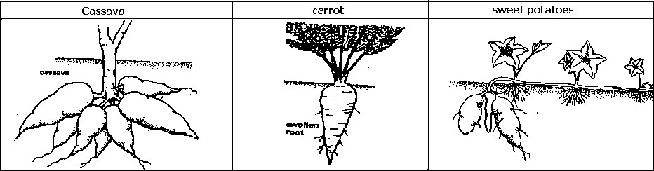

Stem tubers

Stem tubers are crops that store food in their stems.

Examples of stem tubers a. Irish potatoes

b. Yams.

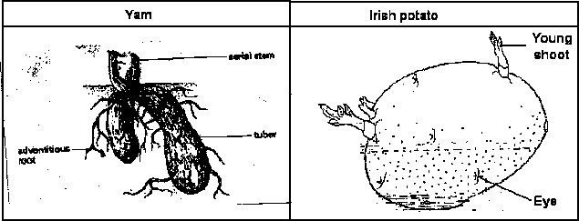

Methods of planting tuber crops Row planting is recommended.

Planting materials.

Crop Material (Part used for propagation)

* + - 1. Cassava Stem cuttings
      2. Sweet potatoes Stem cuttings (vines)
      3. Carrots Seeds
      4. Irish potatoes Stem tuber
      5. Yams Stem tuber

CARING OF CROPS

* + - 1. Pruning.
      2. Thinning.
      3. Weeding
      4. Watering
      5. Spraying with chemicals:

Pesticides

Herbicids

* + - 1. Mulching
      2. Staking
      3. Training

PRUNING

Pruning is the cutting off of some branches or leaves from a plant.

Advantages of pruning

Pruning reduces the rate of transpiration.

Pruning encourages branches to grow big and yield more.

Pruning gives good space for harvesting.

Pruning prevents over crowding on branches on plants.

Pruned materials are used for mulching.

Reduce hiding places for pests.

Note: A pruning saw and Scateur is used for pruning.

MULCHING

Mulching is the covering of soil with dry plant materials.

Plant materials that can be used for mulching a. Dry maize plants.

* + - * 1. Grass cuttings.
        2. Dry leaves.
        3. Coffee husks.
        4. Wood shavings.

Advantages of mulching

* + - * 1. Mulching controls soil erosion. - by reducing the strength of rain drops.
        2. Mulching improves soil fertility. - when mulches rot, they make rthe soil fertile
        3. Mulch maintains soil moisture. - protecting the soil from direct sun heat.
        4. Mulch controls the growth of weeds. - Preventing weeds from receiving

sunlight for making food.

Disadvantages of mulching

a. It is tiresome.

b. Some mulch can grow into weeds.

b. It can easily catch fire and destroy the crops.

a. Can be a breeding place for pests. ( It hides pests).

Note: The main reason for mulching is to maintain soil moisture.

WEEDING

* + 1. Weeding is the removal of unwanted plants from the garden.
    2. Weeds are the unwanted plants in a garden.

Common weeds:

* + - * 1. Wandering Jew.
        2. Black jack.
        3. Spear grass.
        4. Star grass.
        5. Couch grass.
        6. Wild finger millet.
        7. Macdonald’s eye.
        8. Nut grass

Importance of weeds

* + 1. Weeds are source of food for both people and other animals.
    2. Legume weeds improve on the soil fertility by adding nitrogen.
    3. Controlling soil erosion by providing good soil cover.
    4. When weeds rot, they improve on the soil fertility.

Dangers of weeds

* + 1. Weeds lead to poor growth of crops.
    2. Weeds encourage the spread of pests and diseases.
    3. Weeds compete with crops for sunlight, air, soil nutrients and water with crops.
    4. Weeds make it difficult for farmers during pruning, spraying of pesticides and harvesting.
    5. Farmers spend a lot of money on chemicals and labour to control weeds.
    6. Some are poisonous to animals.
    7. Weeds lower the quality of crops.
    8. weeds are hiding places for pests.

Importance of weeding 1. Weeding reduces pests.

* + 1. Weeding reduces competition for sunlight, air, soil nutrients and water between crops and weeds.
    2. Weeding gives good space for pruning, spraying and harvesting.

Ways of controlling weeds

* + 1. Spraying with herbicides.
    2. Mulching.
    3. Uprooting.
    4. Slashing (slashing is normally carried out in crops with wide spacing eg. Coffee and banana plantation)
    5. Cultivating ( Farmers use hoe, tractor or oxen)
    6. Rearing natural enemies.
    7. Crop rotation controls parasitic weeds.

COMMON CROP PESTS FOR ROOT TUBER CROPS

|  |  |  |  |  |
| --- | --- | --- | --- | --- |
|  | Crops |  | Pests | Affected part |
| 1 | Cassava | a | Green cassava mite | Tips of cassava shoot |
|  | b | Mole rats. |  |
| 2. | Sweet potato | a | Sweet potato weevil | Leaves, stem and roots |
| b | Squirrel | Roots |
| c | Mole rats |  |
| c | Eel worms Cut worms | Roots Stems |
| 3 | Carrots |  | Eel worms | Roots |

COMMON CROP PESTS FOR STEM TUBERS

|  |  |  |  |
| --- | --- | --- | --- |
|  | Crops | Pests | Affected part |
| 1 | Irish potatoes | Irish amphid | Leaves |
| 2 | Yams | Mole rats | Stem tuber |

COMMON DISEASES OF ROOT TUBER CROPS

|  |  |  |  |  |
| --- | --- | --- | --- | --- |
|  | Crop | Diseases | | Affected part |
| 1 | Cassava |  | Cassava mosaic | Leaves |
| b | Brown streak | Leaves and tubers |
| 2 | Sweet potato | Sweet potato blight | | Leaves and stem |

Note: The white fly spreads cassava mosaic.

Effects of pest and diseases

* + 1. The leaves and stems lose chlorophyll, this reduces the rate of photosynthesis.
    2. The root tubers get damaged.
    3. The root crops which develop are of a poor quality and do not have the right taste.
    4. Leads to poor yields.
    5. They lead to stunted growth. (plants fail to increase in size).

Methods of controlling pests & diseases of tuber crops.

* + 1. Uprooting infected crops
    2. Proper spacing
    3. Early planting
    4. Spraying with chemicals
    5. Using scare crows
    6. Setting traps
    7. Fencing
    8. Crop rotation

8. Use of noise

9. Chasing

* + 1. Use of natural enemies.
    2. Plant healthy planting materials.
    3. Planting resistant varieties.

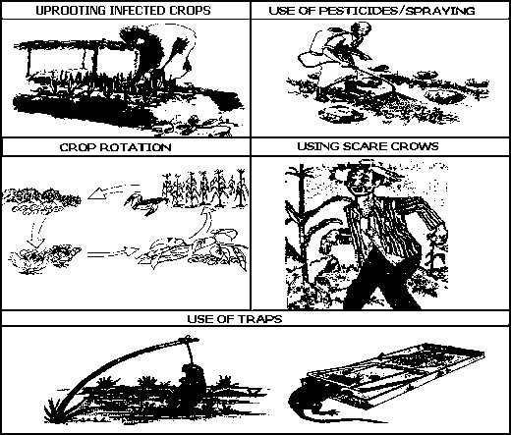

HARVESTING OF TUBER CROPS

* + 1. Harvesting is the picking or removal of ready crops from a garden.
    2. Harvesting should be done when the crops are ready.

Methods of harvesting tuber crops

a. By uprooting.

b. By digging out with a hoe.

NOTE: Harvesting is done during the dry season because there is enough sunshine to dry the harvested crops.

Disadvantages of early harvesting

* + - * 1. Some tubers are poisonous at an early stage.
        2. The quality of tuber is poor.

Processing of tuber crops.

* + 1. Cassava can be processed into cassava chips and dried.
    2. Sweet potatoes can be processed into potato chips and dried.
    3. Irish potatoes can be sliced and deep fried into crisps.

Storage of tuber crops

1. There are different methods of storage for crop produce namely:

* + - * 1. In granaries.
        2. In silos.
        3. In stores

Granaries

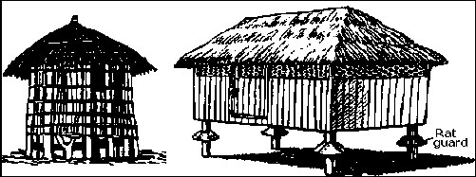

Conditions for proper storage

* + 1. The roofs of stores should not leak.
    2. Stores should have good ventilation.
    3. Rat guards should be fixed on the granary.
    4. Tuber crops should be dried first before storing them.

Note:The above conditions prevent the stored crops from rotting and being attacked by pests.

FARM RECORDS

* + 1. Farm records are written information showing the different inputs and outputs on a farm.
    2. Records kept by crop farmers include the following:
       - 1. The type of planting materials used.
         2. When crops were planted and harvested.
         3. Pests and diseases attacked the crops.
         4. The type of control which was used on the pests and diseases.
         5. The quantity harvested per acre.
         6. Amount of money spent on the inputs on the farm.
         7. Money generated from the produce on the farm.

Uses of farm records

* + 1. Records help the farmer to know whether the farm is making profits or losses.
    2. Records help the farmer to identify areas that need improvement.
    3. Records help the farmer to budget for the farm.
    4. Records help the farmer to avoid repeating mistakes.
    5. Records help the farmers to secure loans.

Young farmers’ club

1. In young farmers’ club, members learn practical skills about the following:

* + - * 1. How to keep animals.
        2. How to keep birds.
        3. How to grow crops.
    1. In some schools, the members have their own gardens where they practise farming.
    2. Some schools make trips or visits to agriculture research stations.
    3. On such study trips members learn through observation and practice how crops and animals are raised and cared for.
    4. Through such trips, members will learn about:
       - 1. Crossbreeding of species.
         2. Artificial insemination.
         3. Biological control of pests and diseases.
         4. Vegetative propagation.

FUNGI

Characteristics of fungi

* + 1. Some exist either as one cell (unicellular) and as many cells (multicellular organisms).
    2. They do not have chlorophyll. This means they cannot make their own food.
    3. They reproduce by means of spores and by budding.
    4. They have nuclei in the cells.
    5. They feed saprophytically or parasitically.

Note: a. Saprophytes feed by absorbing nutrients from decaying matter.

b. Parasites are living organisms that depend on other organisms for both food and shelter.

Examples of fungi

* + - * 1. Mushrooms f. Puffballs
        2. Moulds g. Death caps.
        3. Toadstool h. Yeast
        4. Oysters

MUSHROOM

The structure of a mushroom

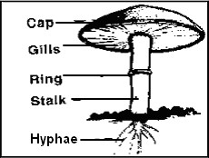

Functions of some parts of a mushroom

Cap

The cap protects the gills

The gills

They produce and store the spores.

The Hyphae

The hyphae absorb nutrients from decaying matter.

How a mushroom reproduce

A mushroom reproduces by means of spores.

Mode of feeding in a mushroom

A mushroom feeds by absorbing nutrients from decaying matter.

MOULDS

* + - * 1. Moulds are thread-like fungi that grow on rotting plant and animals materials such as bread, cassava etc.
        2. Moulds reproduce by means of spores.
        3. Moulds feed by absorbing nutrients from decaying matter. .

TOADSTOOLS

* + - * 1. They grow on decaying plant and decaying animal materials.
        2. Toadstools are poisonous.
        3. Toadstools are brightly coloured unlike the mushrooms.
        4. They feed by absorbing nutrients from decaying matter.
        5. They reproduce by means of spores.

YEAST

* + - * 1. Yeast is a group of fungi that exist as single cells.
        2. Yeast is found on the surface of ripe fruits, mainly sweet-tasting fruits such as mangoes.
        3. Yeast reproduces by budding.
        4. They feed by absorbing nutrients from decaying matter.

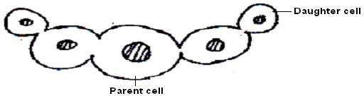

Importance of fungi

* + - * 1. Yeast is a source of Vitamin B1.
        2. Yeast is used in the making or brewing of alcohol.
        3. Fungi help in the decomposition of organic matter.
        4. Penicillium moulds are used to produce medicine, e.g. penicillin antibiotics.
        5. Yeast is used to increase the volume of dough when making bread.
        6. Fungi are a source of local medicine.
        7. Mushrooms are eaten as food.

Harmful fungi

* + 1. Some fungi cause food to go bad and at some time cause food poisoning.
    2. Some fungi cause a number of diseases in plants and animals.

Fungal diseases in plants:

* + - * 1. Rust fungus affects the leaves and stems of cereals.
        2. Root rot in tea plants.
        3. Coffee berry disease in coffee beans.
        4. Potato and tomatoes blight.
        5. Smuts

Fungal diseases in people:

* + - * 1. Ringworm.
        2. Athlete’s foot.
        3. Oral thrush(candidiasis).
        4. Fingernail deformation.

Prevention and control of fungal diseases

* + - * 1. Boil milk, drinking water and reheating cold food
        2. Salting food.
        3. Pickling. (This is the putting of vegetables and other foods in an edible acid like vinegar to preserve it)
        4. Fungal diseases on plants should be sprayed with fungicides.
        5. Avoid warm temperatures and moisture conditions in food materials, these support the growth of fungi.
        6. Avoiding sharing clothes and combs with affected people.

BACTERIA

* + 1. Bacteria are tiny living organisms made up of one cell.
    2. They are so small to be seen using naked eyes.
    3. They are only seen using a powerful microscope. This is why they are called *micro- organism.*

Places where bacteria are found

Bacteria are found almost everywhere, but more especially in the following places:

* + - * 1. Water
        2. In the soil.
        3. In decaying matter.
        4. On the bodies of animals including man.
        5. On plants.
        6. Some bacteria float in air. Types of bacteria
    1. Bacteria are grouped according to their shapes.
    2. There are three types of bacteria commonly found in our surroundings:
       - 1. The spherical called cocci (plural) or coccus (singular).
         2. Rod shaped called bacilli.
         3. Spiral e.g. spirilla and the spirochaete.

The spherical shaped called cocci or coccus

These cause boil These cause sore throat These cause pneumonia

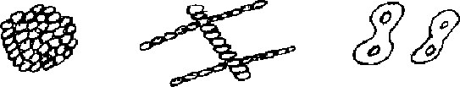

Rod shaped called bacilli

Rod or cylindrical called bacilli among these cause anthrax, typhoid and food poisoning.

These cause anthrax These cause typhoid fever

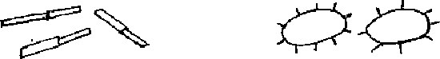

The spiral bacteria

These cause syphilis. These cause cholera.

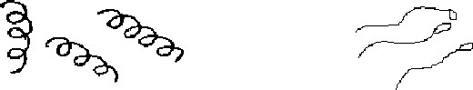

Useful/harmless bacteria to man

* + 1. Some useful bacteria help in the making of vitamin B12, and vitamin K.
    2. Useful bacteria help in making cheese butter and yoghurt by fermenting milk.
    3. Useful bacteria help in digestion of food in ruminants.
    4. They are used to break down volumes of garbage and faeces in latrines, septic tanks and sewage systems.

Useful/harmless bacteria to soil

* + 1. Bacteria help in the decaying and rotting of organic matter
    2. Nitrogen fixing bacteria found in root nodules of legumes trap nitrogen from the air and change it to nitrates.

Note: That is why it is not good to pour dangerous chemicals like paraffin and insecticides in latrines.

Similarities between bacteria and fungi

a. They both cause diseases.

* + - * 1. They both have two ways of feeding that is parasitically or saprophytically.
        2. They are both living organisms.

Differences between bacteria and fungi

* + 1. Most fungi reproduce by means of spores while bacteria reproduce by means of binary fission. (cell division)
    2. Bacteria are single celled while most fungi are multicellular

**P.5 SCIENCE LESSON NOTES**

**TERM III**

CHANGES IN OUR ENVIRONMENT

There are three changes in our environment: a. Chemical changes.

* + - * 1. Biological changes.
        2. Physical changes.

CHEMICAL CHANGES

Chemical changes are changes in which new substances are formed from.

Characteristics of chemical changes

a) The changes are irreversible.

* + - * 1. A new substance is always formed.
        2. There is a change in weight.
        3. Heat or light or both are produced.

Examples of chemical changes

* + 1. Burning of wood to ash.
    2. Rusting of metals.
    3. Burning of candle wick to ash
    4. Burning of paper to ash
    5. Burning of wood to charcoal..

PHYSICAL CHANGES

Physical changes are changes in which no new substances are formed.

Characteristics of physical changes

i. The changes are reversible.

ii. No heat or light is given out.

iii. There is no change in weight.

iv. There is no new substance formed.

Examples of physical changes

* + 1. Melting of ice to water.
    2. Melting of plastic.
    3. Melting of butter.
    4. Melting of candle wax.
    5. Freezing of water to ice.
    6. Evaporation of water to steam.
    7. Water turning into water.
    8. Vapour turning into water.

BIOLOGICAL CHANGES

Biological changes are changes which take place in the life of living things.

Characteristics of Biological changes

* + - 1. Young ones grow mature and become old.
      2. Small ones change size and become big.

Examples of biological changes

1. Body growth.

* + 1. Development of breasts in females.
    2. Growth of nails in animals.
    3. Growth of hair.
    4. Growing of a seed to seedlings/Germination.

OTHER CHANGES IN THE ENVIRONMENT

* + 1. Formation of clouds.
    2. Temperature change.
    3. Occurrence of day and night.

Man made changes

* + 1. Man has built roads
    2. Draining swamps.
    3. Man has improved on animals, plants and birds by crossbreeding.
    4. Man has built bridges across rivers, lakes and valleys.
    5. Forests have been cut to create land for Agriculture.
    6. Man has planted trees.

Natural changes

* + 1. Earthquake
    2. Drought
    3. Floods
    4. Change in season
    5. Land slides
    6. Rain formation
    7. Days and night

Effects of various types of changes to people, animals and plants

* + 1. People change from young one to old ones and later die.
    2. Animals grow old and become useless.
    3. Plants grow and later die.
    4. Some animals are improved by crossbreeding.
    5. New varieties of seeds are produced after research work.
    6. Through research, plants and animals grow and mature quickly.
    7. Cutting trees cause drought.
    8. Earthquakes destroy life and property.
    9. Droughts cause plants to die.
    10. Floods destroy property and lives.

GOATS

Reasons for keeping goats

* + 1. Meat production.
    2. Milk production.
    3. Skin.
    4. Some provide us with mohair.
    5. Source of income.
    6. Cultural purposes.
    7. Hooves and horn are used in the making of buttons and glue.
    8. Animal droppings are used as manure (farmyard manure) External parts of a goat

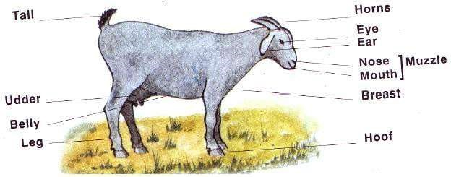

|  |  |  |
| --- | --- | --- |
|  | Breeds of goats reared in Uganda | |
| 1. | Mubende goats. | |
| 2. | The East African small goats. | |
| 3. | Boar goats. | |
| 4. | Saanen | |
| 5. | The Somali goats.(Galla) | |
| 6. | Toggenburg | |
| 7. | Anglo Nubian  Mubende goats |

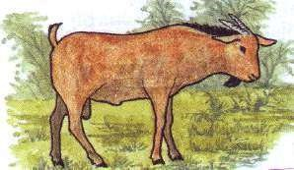

* + 1. A mubende male goat is widely kept in Uganda.
    2. It weighs between 40kg to 50 kg when mature.

The East African small goats

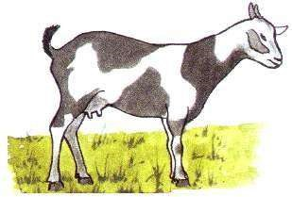

* + 1. The East African small goats are widely kept in Uganda, Kenya and Tanzania.
    2. A mature goat can weigh between 25kg to 30kg.
    3. The East African small goats are of mixed colours.

The Somali goats (Galla)

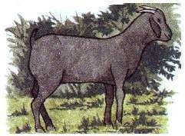

* + 1. Galla goats are kept in most parts of East Africa.
    2. They were imported from Somalia.

Saanen goats

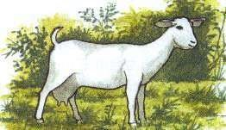

Saanen goats are white in colour.

* + 1. They produce a lot of milk.
    2. They were imported from Switzerland.

Toggenburg

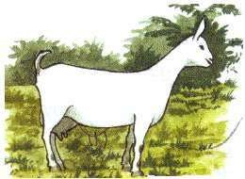

* + 1. It can weigh up to 40kg when mature.
    2. It holds (keeps) its ears (erect) upright.

NOTE: a. Saanen, Anglo nubian and Toggenburg are special breed mainly for dairy (milk production).

b. Angora goats are kept for its mohair. Reasons for housing goats

* + 1. To protect them from bad weather.
    2. To prevent them from destroying crops.
    3. To control spread of diseases and parasites.
    4. To protect them from wild animals.

GRAZING

1. Grazing is the act of eating grass by livestock.

Examples of livestock: a. Cattle

* + - * 1. Goats
        2. Sheep
        3. Pigs
        4. Poultry.

Types (methods) of grazing livestock a. Free grazing

* + - * 1. Tethering method
        2. Paddock grazing
        3. Zero grazing

FREE GRAZING.

Free grazing is when goats are left to roam about to graze on their own.

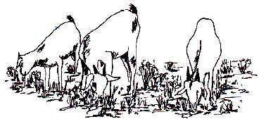

Advantages of free grazing

* + 1. Animals get a variety of food which may enable them to get a balanced diet.
    2. Animals get enough physical exercises as they move round looking for their food.
    3. Free grazing cuts down the cost of feeding.
    4. Manure in form of droppings is distributed all over the area the animals feed from.

Disadvantages of free grazing

* + 1. The animals can easily get diseases and parasites.
    2. The animals can get lost.
    3. Thieves can easily steal the animals.
    4. The animals can destroy crops.
    5. The animals can be eaten by wild animals.

TETHERING METHOD OF GRAZING.

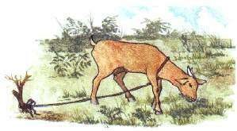

* + 1. This is a method of grazing where animals are tied on a peg as they graze.
    2. This method of grazing allows the animals to eat pasture around it.
    3. Other feeds may be given to the animals at the position where they are tied.

Advantages of tethering method.

* + 1. It is very easy to collect manure.
    2. Farmers with small land can also keep animals using this method.
    3. It is easy to control parasites and diseases.

Disadvantages of tethering method.

* + 1. The rope may injure the animal.
    2. This method is only suitable for a few animals.
    3. Replacement of worn out ropes tends to be costly.
    4. The animals feeding is limited to the radius of the rope.
    5. The animals can easily be attacked by wild animals.

PADDOCK GRAZING

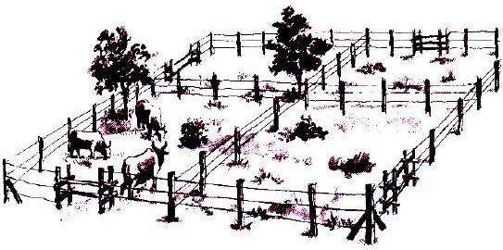

* + 1. This is the method of grazing where land is divided into small plots called paddocks.

* + 1. Animals are grazed on one paddock for a few days before they are taken to another paddock.
    2. When animals are grazed in one paddock, pasture in the already grazed paddocks is growing again.

Advantages of Paddock grazing

* + 1. It controls soil erosion.
    2. It controls overgrazing.
    3. Grass is given time to grow.
    4. Manure is distributed evenly in the pastureland.
    5. It is easy to control parasites (worms and ticks).
    6. Pasture is properly used.
    7. Farmer gets time to do other activities.

Disadvantages of paddock grazing.

* + 1. This method of grazing requires a big piece of land.
    2. It is expensive to construct the paddocks.

ZERO GRAZING.

* + 1. Is the method of grazing where animals are kept in a sheltered place all the time and are fed from there.
    2. Farmers who have small pieces of land mainly practice zero grazing.

Advantages of zero grazing.

* + 1. It is easy to control parasites and diseases.
    2. Farmers with small piece of land can also keep animals.
    3. It is very easy to collect manure.
    4. Animals are more protected against bad weather.
    5. Animals yield more.

Disadvantages of zero grazing.

* + 1. It is expensive to maintain.
    2. Animals lack enough physical exercises since they are indoors all the time.
    3. It is tiresome to collecr pasture for the animal.
    4. It requires a lot of labour to clean the animal shelter everyday.

DISEASES THAT ATTACK GOATS

|  |  |  |
| --- | --- | --- |
|  | DISEASE | CAUSE |
| 1 | Anthrax | bacteria |
| 2 | Pneumonia | bacteria |
| 3 | Foot root | bacteria |
| 4 | Heart water | protozoa |
| 5 | Nagana | protozoa |
| 6 | Red water | protozoa |
| 7 | Coccidiosis | protozoa |
| 8 | Nairobi disease | virus |
| 9 | Foot and mouth disease | virus |
| 10 | Rinder pest | virus |

Parasites that attack goats

1. Internal parasites that attack goats include:

* + - * 1. Tape worms
        2. Liver fluke
    1. Internal parasites can be controlled by Deworming

* + 1. External parasites that attack goats include:
       - 1. Ticks
         2. Mites
         3. Lice

4. External parasites can be controlled by:

* + - * 1. Spraying using acaricides.
        2. By dipping.
        3. Hand picking.
        4. Paddock grazing.

Spraying using acaricides to kill external parasites

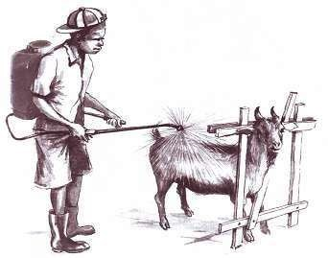

Terms used in goats keeping.

i. Kidding - Is the act of giving birth to a young goat.

ii. Kid - A young one of a goat.

iii. Billy - A mature male goat.

1. Nanny - A mature female goat.
2. Mohair - Hair got from goats.
3. Gestation period - The time a nanny goat gets pregnant to giving birth.

Note. The gestation period of goats is five months.

SHEEP

Types of breeds of sheep

* + - 1. Local breeds
      2. Exotic breeds

Local breeds

* + 1. Local breeds of sheep are widely kept in most parts of Uganda.
    2. Examples of local sheep kept in Uganda:
       1. Black head Persian
       2. The Masai
       3. The Somali sheep

Black head Persian

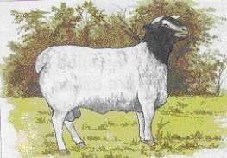

|  |  |
| --- | --- |
|  | The Masai |

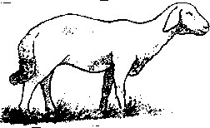

Exotic (foreign) breeds

* + 1. These breeds were imported from out side countries.
    2. Examples of exotic sheep kept in Uganda:
       1. The merino sheep
       2. Hampshire Down
       3. Romney marsh
       4. Corriedella The merino sheep

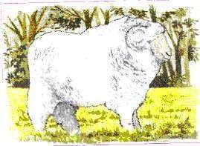

Hampshire Down

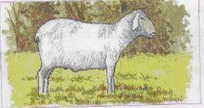

3. Special breeds of sheep kept for wool production include:

* + - 1. The merino sheep
      2. Romney marsh

DOCKING

* + 1. Docking is a practice of cutting short the sheep’s tail.
    2. Female sheep are commonly docked.

An illustration of a docked sheep

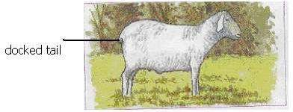

Reasons for docking

* + 1. For easy mating.
    2. To remove hiding places for parasites.
    3. For hygienic purposes.

Ways of docking animals

Sheep are docked using a sharp knife.

Gestation period of a sheep

The gestation period of a sheep is 150 days (5 months).

TERMS USED IN SHEEP KEEPING

1. RAM

A ram is a mature male sheep.

2. A EWE

A ewe is a mature female sheep.

3. LAMB

A lamb is a young one of a sheep.

* + 1. LAMBING

Lambing is the giving birth to a lamb by a ewe.

* + 1. DOCKING

Docking is the practice of cutting short of sheep’s tail.

PIGGERY

Piggery is the rearing and management of pigs.

BREEDS OF PIGS

* + - 1. Exotic breed of pigs.
      2. Local breeds of pigs.
      3. Crossbreeds.
      4. Wild pigs.

LOCAL BREED OF PIGS

* + 1. These are the pigs whose origin is within the country.
    2. These local breeds of pigs can be improved by cross breeding.
    3. Local breeds of pigs are also referred to as indigenous breeds of pigs.

WILD PIGS

* + 1. These are the pigs commonly found in bushes
    2. Examples of the wild pigs are the warthogs.
    3. Wild pigs are sometimes known as untamed pigs.

CROSS BREEDS

Crossbreeds are got as a result of mating of two different breeds.

EXOTIC BREEDS OF PIGS

Exotic breeds are sometimes called foreign breeds.

Characteristics of exotic breeds of pigs.

* + - 1. They have the same colour, shape and size when mature.
      2. They produce a lot of pork; bacon or skin.
      3. They have the same ability to produce the same number of piglets.
      4. They grow and mature fast.

Examples of exotic breeds.

a. Land race.

* + - 1. Large white
      2. Middle white.
      3. Hampshire.
      4. Poland China.
      5. Wessex saddle back.
      6. Large black. LARGE WHITE.

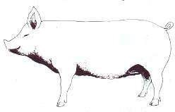

* + - 1. It’s the most common breed in East Africa.
      2. It’s white in colour.
      3. Large white is also known as Yorkshire.

LANDRACE.

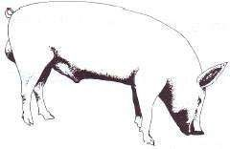

* + - 1. It is white in colour.
      2. It is good for bacon.
      3. Bacon is the meat got from the back and sides of a pig.

|  |  |
| --- | --- |
|  | 1. Middle white is white in colour. 2. It is smaller than the large white.   WESSESX SADDLE BACK |

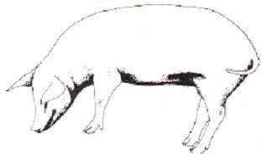

**MIDDLE WHITE**

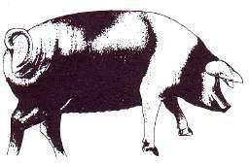

It is black with a white strip (saddle) at the shoulder.

SYSTEMS OF KEEPING PIGS

There are two systems commonly used to keep pigs: a. Extensive system

b. Intensive system

EXTENSIVE SYSTEM

* + 1. This is the system in which pigs are allowed to roam about and housed at night.
    2. Extensive system is also known as outdoor system.

Advantages of extensive system

* + 1. It is cheap to maintain.
    2. Cuts costs of feeding because pigs look for their food.
    3. Pigs get enough physical exercises.
    4. Pigs get a balanced diet.

Disadvantages of extensive system

* + 1. Pigs can easily destroy crops.
    2. Can easily be stolen.
    3. Easy spread of diseases and parasites.
    4. It is hard to keep health records.

INTENSIVE SYSTEM

* + 1. It is a system in which pigs are kept and fed indoor.
    2. This system is also known as indoor system. 3. Pigs are kept in small structures called sties.

Advantages of intensive system

* + 1. Pigs are usually free from infections.
    2. Pigs grow and mature quickly.
    3. Farm records are easy to keep.
    4. Diseases and parasites are easy to control.
    5. Low death rates due to close attention.
    6. Animals yield more.

Disadvantages of intensive system

* + 1. It is expensive to maintain.
    2. It needs close attention.
    3. It is tiresome to clean the sty every day.

The internal structure of a modern sty

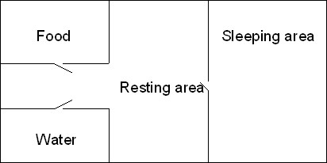

HOUSING OF PIGS

* + 1. A house for pigs is called a sty.
    2. Things or factors considered when constructing a sty:
       1. A sty should be well ventilated.
       2. A sty should be constructed in a well-drained area.
       3. The area should be warm and dry.
       4. The sty should be large enough for easy cleaning.
       5. The floor should be made slanting for easy cleaning.

GESTATION PERIOD OF A PIG

* + 1. Gestation is the period from fertilization to birth.
    2. The gestation period of a pig is three months, three weeks and three days.
    3. During the last 45 days of the gestation the sow should be steamed up.

STEAMING UP

Steaming up is a special feeding a pregnant animal on foods rich in proteins.

Advantages of steaming up

* + 1. The animal builds up its body in preparation to give birth.
    2. Steaming encourages the foetus or embryo to grow well.
    3. Steaming up leads to increased milk production by the sow.
    4. Steaming up prevents low birth weight.
    5. Steaming up lengthens the lactation period.

Note. Lactation is the period through which a sow is able to produce milk.

CASTRATION

Castration is the removal of testes from the male animals.

Method of castration

* + - 1. Open operation.
      2. Closed operation.
      3. Use of the loop.

Open operation.

* + 1. This is when a knife is used to cut a slit to open the scrotum vertically.
    2. The testes are removed.
    3. A hot iron is used to burn and seal off the sperm duct.
    4. The wound is then disinfected using dettol or any other disinfectant.

Closed operation.

1. This is where an instrument called a burdizzo is used to destroy or crash the sperm duct.

A diagram of a burdizzo.

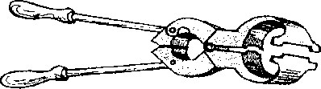

Use of the loop.

* + 1. In this method, an elastic rubber band is used to squeeze the sperm duct.
    2. When the sperm duct and the blood vessel are broken, the testes shrink.

Reasons for castration

* + 1. Castration makes animals docile.
    2. Castrated animals tend to grow faster than uncastrated animals.
    3. Castration prevents in breeding.
    4. Castrated animals can be grazed or kept with females without trouble.
    5. Castrated animals tend to fatten.
    6. Prevent bad smell.

RUMINANTS

* + 1. Ruminants are animals that chew cud.
    2. Ruminants have four stomachs.
    3. Examples of ruminants:
       1. Cattle
       2. Sheep
       3. Goats

NON-RUMINANTS

|  |  |  |
| --- | --- | --- |
|  | 1. | Non-ruminants do not chew cud. |
|  | 2. | Non-ruminants have one stomach. |
|  | 3. | Examples of non-ruminants:   1. Pigs 2. Man 3. Rabbits   The digestive system of a pig. |

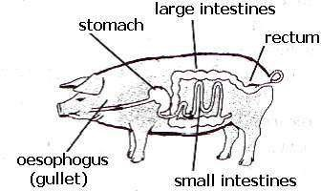

|  |  |  |
| --- | --- | --- |
|  | 1.  2. | Terms used in piggery  Boar - mature male pig.  Sow - mature female pig. |

* + 1. Piglet - young ones of pigs.
    2. Hog - castrated male pig.
    3. Gilt - immature female pig.
    4. Pork - meat from pigs.
    5. Farrowing - the act of producing piglets.
    6. Lard - fats got from pigs.

|  |  |
| --- | --- |
|  | DISEASES THAT ATTACK PIGS |

|  |  |  |  |  |
| --- | --- | --- | --- | --- |
|  | **Disease** | **Cause** | **Signs And Symptoms** | **Prevention And Control** |
| **1** | African swine fever | virus | 1. Fever. 2. Staggering. 3. Weakness 3. Difficult in breathing. 4. Diarrhoea   6 Constipation  7. Sudden death | 1. Has no treatment. 2. Keep pigs in door. 3. Cull the pigs. 4. Disinfect the pig house. 5. Apply quarantine. |
| **2** | Foot rot | bacteria | 1. Lameness due to blisters. 2. Fever. 3. Dullness 4. Loss of appetite. | 1. Treat with antibiotics. 2. Isolate sick animals. 3. Vaccinate the pigs. 4. Cull sick animals. 5. Apply quarantine. |
| **3** | Anthrax | bacteria | 1. Fever 2. bleeding through the nose and anus. | 1. Treat with antibiotics. 2. Burry or burn carcass. 3. Vaccinate the pigs. 4. Report suspected anthrax as soon as possible. 5. Don’t eat meat from suddenly dead animals. |
| **4** | Pneumonia | bacteria | 1. Watery discharge from the mouth and nose. 2. High temperature. 3. Coughing 4. Difficulty in breathing 5. Loss of appetite | 1. Treat with antibiotics. 2. Provide the pigs with enough space. 3. Proper ventilation in the sty. 4. Keep the pigsty warm and dry. |
| **5** | Nagana  (trypanosomias  is) | Protozoa | 1. Fever. 2. Dullness 3. Loss of appetite. 4. Runny eyes that lead to blindness. 5. Loss of weight. 6. death may occur after several weeks. 7. Anaemia | 1. vaccinate the pigs. 2. clear all the bushes to keep away tsetse flies. |
| **6** | Piglet anaemia | Lack of iron |  | Administering iron injection |

FOOD AND NUTRITION

* + 1. Feeding

Feeding is the taking in of food.

* + 1. Food

Food is something that is good to eat.

BREAST FEEDING

* + 1. Is a natural way of feeding in which a baby sucks milk from the mother’s breasts.
    2. It is recommended that a mother should breast feed her baby up to 2-3 years.

Advantages of breast feeding to a baby

* + 1. Breast milk provides the baby with all the nutrients.
    2. Breast milk is easily digested.
    3. Breast milk provides the baby with anti-bodies.
    4. Breast milk is always at the right body temperature.

Note: colostrum is the milk produced by an animal in the first four days after delivery.

Advantages of breast feeding to a mother

* + 1. Breast feeding can delay the next pregnancy.
    2. Breast feeding is cheap to the family in terms of expenditure.
    3. Breast feeding is time saving.
    4. Breast feeding improves the health of the mother, as she has to eat in order to maintain breast milk.

BOTTLE FEEDING

* + 1. This is an artificial way of feeding in which a baby sucks milk from the bottle.
    2. If bottle-feeding is done properly, it can substitute breast feeding in case the mother is not around most of the time.

Factors that make a baby be bottle fed 1. In case the mother is dead or not around.

* + 1. When the mother has AIDS.
    2. When the mother has severe breast cancer.
    3. When a baby refuses breast milk. 5. When the mother’s breast cannot produce enough breast.

Disadvantages of bottle feeding

* + - 1. Bottles can easily be contaminated by houseflies.
      2. Bottles are difficult to clean properly causing germs to grow and spread.
      3. Bottle milk can get contaminated causing sickness to the child.
      4. Cow’s or tinned milk or powdered milk is expensive to buy.
      5. Some babies are allergic to cows milk.

WEANING CHILDREN

Weaning is the gradual introduction of solid foods to a baby’sdietin addition to breast milk.

Reasons for weaning at six months

* + 1. The baby needs more nutrients because the body is growing.
    2. To prevent deficiency diseases.
    3. The baby needs to get iron from other foods because breast milk does not contain it.
    4. To supplement on breast milk.

Common foods used during weaning

* + - 1. Mashed Irish potatoes.
      2. Porridge.
      3. Sweet banana.
      4. Mashed egg yolk.
      5. Mashed beans.

Note: Weaning is done at the age of six months to supplement breast milk.

FOOD TABOOS AND BELIEFS

A taboo is a cultural or religious custom that forbids people from eating certain types of food.

Examples of religious food taboos

* + 1. Moslems are not allowed to eat pork.
    2. Moslems are not allowed to eat meat of an animal slaughtered by a non-moslem.
    3. Catholics do not eat meat on Fridays during lent.

Examples of cultural food taboos

* 1. In Buganda, girls and women were not allowed to eat chicken and eggs because they make them barren.
  2. Men were not allowed to eat oil nuts because they can make them impotent.
  3. Children suffering from measles are not allowed to eat meat because it makes them more sick.
     1. Babies were not allowed to eat liver and eggs because they make them take long without talking and also make them urinate and defecate on their beds.

Advantages of food taboos and beliefs

* + 1. Certain people and tribes have plenty of foodstuffs to eat.
    2. Certain animals and plants are conserved in areas where they are not eaten.

Disadvantages of food taboos and beliefs

* + 1. Food beliefs and taboos can result into malnutritional diseases.
    2. Pregnant women may become malnourished and produce underweight babies.

VULNERABLE GROUPS OF PEOPLE

These are groups of people whose health can easily be harmed if they are not given enough of the correct food to eat.

Examples of vulnerable groups of people: a. Pregnant women.

* + - 1. Sick people.
      2. Elderly people.
      3. Weaning children.
      4. Breast feeding mothers.
      5. Breast fed babies.

PREGNANT WOMEN

* + 1. Pregnant women need to eat food that will be enough for themselves and for the foetus growing in their wombs.
    2. A pregnant woman needs a balanced diet containing the following:

Proteins

To build the body tissues of the foetus growing inside her womb and also repair the worn out cells on her body.

Carbohydrates

To give enough energy to carry the in their womb.

Iron

To enable formation of more blood enough for the mother and the foetus.

Calcium

To build strong bones of the foetus inside the womb

Vitamins

To protect her and the foetus from certain diseases

SICK PEOPLE

1. Sick people need food and extra fluids in order to help the body to fight sickness.
2. Most of the foods include the following:

Proteins

Proteins to repair worn out cells during sickness.

Vitamins and mineral salts

The most important are vitamin C, calcium and iron to build the body defence and also help in the manufacture of blood.

Fluids

Fluids to prevent dehydration. Such foods include clean boiled water, fruit juice, soup from meat, chicken or fish.

Frequent feeding

Sick people may not be able to eat very much at one time so they should be fed with easily digestible foods.

ELDERLY PEOPLE

1. When people grow old, they often lose their teeth which cause health problems such that they do not crush their food for easy digestion which can cause indigestion or constipation.
2. Elderly people need the following:
   1. Foods that are easy to eat such as minced meat, mashed fruits etc.
   2. Frequent feeding because they may not be able to eat very much at one time.
   3. Stomach walls are weak to churn the food.

STAPLE FOODS FOR DIFFERENT COMMUNITIES

A staple food is the food commonly eaten by a particular community.

Common staple foods. a) Matooke

* 1. Millet
  2. Maize
  3. Cassava.
  4. Sweet potatoes
  5. Irish potatoes.
  6. Yams
  7. Sorghum.

Examples of staple foods for different communities

The Iteso a) Millet

* 1. Cassava for mixing the millet.
  2. Sorghum

The Baganda

* + 1. Matooke.
    2. Cassava
    3. Sweet potatoes.

The Basoga

* 1. Sweet potatoes.
  2. Cassava.
  3. Millet.
  4. Yams

The Banyankole a) Matooke.

* 1. Millet
  2. Cassava
  3. Irish potatoes.

The Acholi and langi. a) Cassava

* 1. Millet.
  2. Sorghum

Reasons why different communities prefer the above foods. a) Climate in the regions favour their growth.

b) The type of soils in their areas.

PRIMARY HEALTH CARE

1. Primary Health Care is the essential health care where individuals, families or communities work together to solve their own health problems.
2. Primary Health Care is commonly abbreviated as PHC.

Note: Health is the state of physical, social and mental welfare.

Elements of Primary Health Care a. Sanitation

* 1. Family planning
  2. Nutrition
  3. Immunisation
  4. Hygiene
  5. First aid
  6. Antenatal and postnatal care.
  7. Provision of safe water.

Principlals of PHC

* 1. Equal care for every for everybody.
  2. It should be affordable for all.
  3. It should be accessible to all.
  4. It should be available to all.

Some of the ways how to inform and educate people

1. Through songs, plays, story telling which interest and excite people to increase their activities in health.
2. Through radio, news papers, talks and discussions with health staff and community health workers.
3. School pupils can pass health information to their relatives and community in general.

AN INDIVIDUAL AND PRIMARY HEALTH CARE

1. Bathing regularly.
2. Brushing teeth every after a meal.
3. Cutting finger nails short.
4. Washing hands after visiting the toilets.
5. Washing hands before and after eating.

FAMILY AND PRIMARY HEALTH CARE

The family can participate in Primary health Care by: a. Collecting and burrying rubbish.

* 1. Boiling drinking water.
  2. Fetching water.
  3. Washing utensils.
  4. Scrubbing the toilet.
  5. Sweeping the compound.
  6. Elders educating the young ones how to keep health.
  7. Preparing a balanced diet.

THE COMMUNITY AND PRIMARY HEALTH CARE

1. A community is a group of people living and working together in the same locality.
2. A community can participate in Primary Health Care by:
   1. Organising regular community clean up campaigns to do the following:
      1. To pick up broken glass.
      2. To pick up plastic bags and papers.
      3. Sweeping and removing rubbish.
   2. Reporting any unusual occurrence of a disease in a community.
   3. Assist in community education i.e. talking to groups about health, discussing a radio or Television programme on health.
   4. Ensuring that all children in a community are immunised.
   5. Protecting wells and other water sources, construction of communal, rubbish pits, latrines.

Suitable lifestyles and good health practices.

* + 1. Observe proper hygiene of the body and food.
    2. Observe proper sanitation.
    3. Eat foods containing a balanced diet.
    4. Smoke and keep pit latrines clean and always flash toilets after use.
    5. Dump household garbage in dustbins or waste pits and burry them.
    6. Cover left over foods or reheat food before eating.
    7. Utensils and cutlery should be kept clean all the time.

h. Avoiding alcoholism, drug abuse and smoking.

PEOPLE WITH SPECIAL NEEDS.

These are groups of people who need special help to enable them survive.

Examples of people with special needs a. The sick.

1. The Elderly.
2. The disabled.
3. The young.

THE SICK, INVALID AND CONVALESCENT

A sick person

This is a person suffering from a disease or an illness and has shown signs and symptoms of a disease.

An invalid

An invalid is a person who is totally down with sickness and can not help him or herself.

Convalescent

A convalescent is a person getting treatment and is recovering after an illness or sickness.

How to care for the sick, invalid and convalescent

The following must be observed: a. Washing for them their clothes

1. Preparing their beds.
2. Preparing their food.
3. Reminding them to take medicine.
4. Bathing them.
5. Taking them to health centers.

How to care for the elderly

1. Washing for them their clothes
2. Preparing their beds.
3. Preparing for them a balanced diet.
4. Giving them easily digestible food.
5. Giving them company
6. Helping them to bathe.
7. Taking them to health centers for routine check ups.
8. Helping them to do some physical exercises.

How to care for the disabled

* 1. Helping them get water.
  2. Helping them reach where they can’t.
  3. Helping them get a balanced diet.
  4. Help them understand messages through sign language.
  5. Helping them maintain their hygiene.
  6. They need devices to help them hear, see or walk.

How to care for the young

1. They need a balanced diet to prevent deficiency diseases.
2. The young need protection.
3. The young need medication.
4. They need to maintain their hygiene.

SCHOOL HEALTH CLUB

1. A school health club is composed of teachers, pupils, community health workers and interested parents.
2. It is advisable for every school to have a School Health Club.

Activities of a School Health Club

1. It prepares health campaigns against pupils who smoke and drink alcohol.
2. It prepares health campaigns for immunisation.
3. It invites health workers to talk to pupils about health matter.
4. A health club raises money for the first aid kit.
5. It organises members at school to clean the school by picking litter. HEALTH PARADES

These are assemblies intended to check children’s health and hygiene.

Activities carried out on health parade.

1. Teachers check r children whose heads and bodies are not well cleaned.
2. Teachers check children whose nails are not well groomed.
3. Teachers check children who do not brush their teeth.
4. Teachers check children who do not comb their hair.
5. Teachers check children who do not clean their clothes and bags.

Note: While checking is going on, records are made on each individual child.